Year One October Holiday Homework
Look at the ideas listed below. Choose two or more activities to complete.

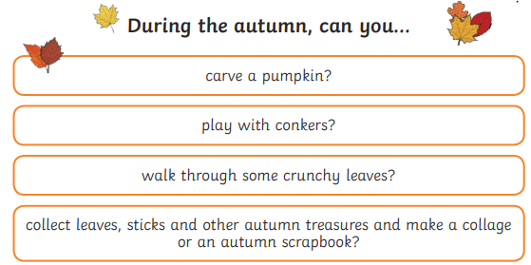

Choose from the list of autumn ideas above
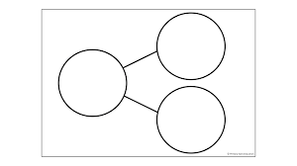  Can you use the part whole model to write number sentences to 10 or 20? | Can you name the days of the week in order?  Can you remember the months of the year?  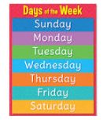  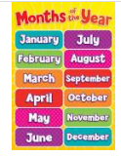
Can make your own animal mask. You could use bits of material, cereal boxes, scraps of ribbons, newspaper,  or anything else that takes your fancy.  Choose an animal you might see in the UK in Autumn:  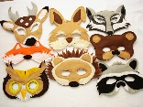 | Can you say the sound and the name for each letter of the alphabet?  