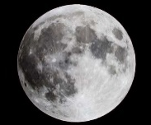
How do you become an explorer?
Find out and write down 10 facts about the Moon  (2 points) | 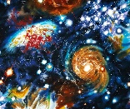  Use scrap paper, foil, sweet wrappers and other junk around the house to create a space collage. (3 points) | Make a model rocket for an astronaut to use. (3 points)
What 5-10 things would you take with you on a trip to outer space? Write a list and give a reason for each object (minimum = 5 things)  (3 points) | Design a menu for an astronaut using healthy foods.  (3 points) | 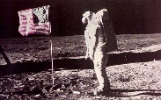  Write a letter to Neil Armstrong telling him why you should be the next Astronaut to go to the moon. (3 points)
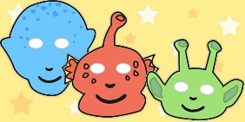  Design and create an Alien mask.  (2 points) | Compare the sizes of different planets using words like longer, shorter, wider, narrower, bigger and smaller (3 points)  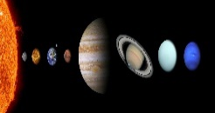 | 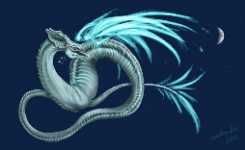  Imagine that you land on the moon. You see a moon creature! Draw it. Write labels and captions to make it clear what type of creature it is!  (2 points)  (2 points)
Write out some rules about living on the moon. Make it into a poster.  (2 points) | Make a telescope from recycled objects and decorate this with some useful facts about space. (3 points) | Have fun completing these activities. In the next 6 weeks you MUST complete 6 activities or more!!!  It is entirely up to the children which activity they pick. All homework to be handed in by Monday 13th December 2021
Homework Menu
Bronze certificate - 11 points Silver certificate - 18 points Gold Certificate - 25 points

