Wibsey Primary School Skills for Life Year 6
© Adapted from the PSHE Association Programme of Study and the EYFS Statutory Framework by Nicole Cooper for Wibsey Primary School, Bradford.

In year 6 we have been thinking about stereotypes and we had a really interesting lesson where challenged some of the stereotypes that we have. It was a SCARF game where we needed to look at pictures of people and try to guess their job simply from looking at their appearance.
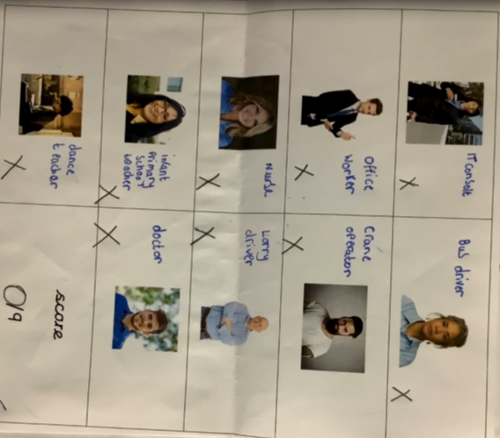

Boys can play with dolls!
Girls can like other colours and not just pink!
It made us realise that we should not judge make judgements about people based on appearances and we started to think about other stereotypes that can be negatively reinforced. When we searched for ‘girls’ toys’ online, this is what we found and we were very angry!
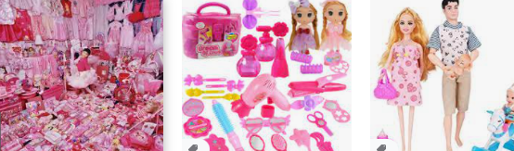

We thought this person was an office worker based on the fact that they were wearing suit - we were wrong!
We thought this person was a crane worker because they had a beard and tattoos - we were wrong!

