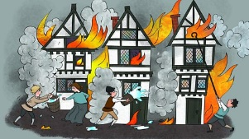
Who started the fire?
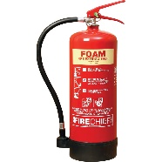  Design a poster to promote fire safety.  (2 points) | Write a list of instructions on how to bake bread. (2 points)  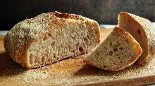 | Make an apron for a baker. What materials will you use?  (3 points)
Design and draw your own hot cross bun. What will you have on the top? A cherry or raisins?  (3 points) | 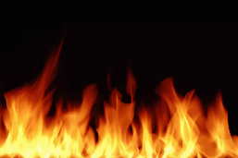  Write some sentences warning people of the dangers of fire.  (3 points | 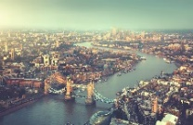  Locate the River Thames on a map. Write down facts and information about the River Thames. (4 points)
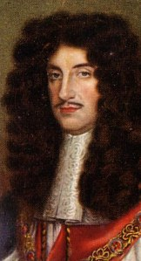  Draw a portrait of our Queen and King Charles II. Write down any interesting facts about these two monarchs. (3 points)  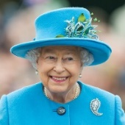 | 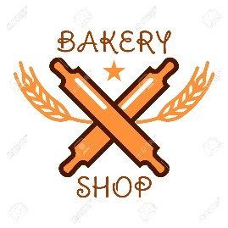  Draw a shop sign for the bakery on Pudding Lane.  (2 points) | Make a sketch of a Tudor building.  (2 points).
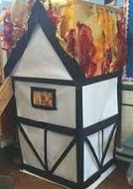  Make a shoebox model of the Great Fire of London.  (4 points) | Practise using the method of partitioning 2-digit numbers in different ways. (3 points)  E.g. 41 + 5 = 46  31 + 15 = 46  21 + 25 = 46  11 + 35 = 46  1 + 45 = 46 | Have fun completing these activities.  Each week please try to select and complete one activity from the grid.  All homework to be handed in by  Monday 14th February 2022
Homework Menu
Bronze certificate - 11 points Silver certificate - 18 points Gold Certificate - 25 points

