Nursery Holiday Homework
Next half term the Nursery’s big question is
‘What did you see on your journey?’

Our special story will be
‘We’re Going on a Bear Hunt’ by Michael Rosen

Here are some of the special words from the story. Why not ask an adult or older brother/sister to look at the pictures and talk to you about what the words mean.

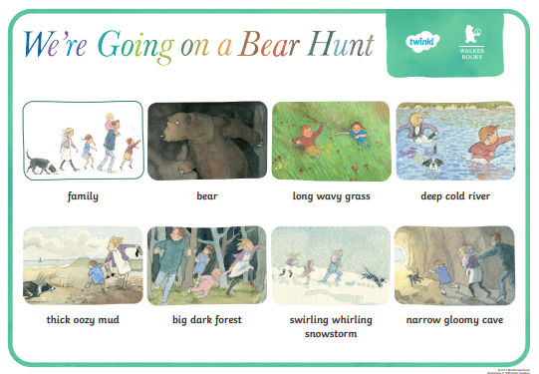
Now go on your own journey.
Where will you go?
What will you see/hear/smell?

