Reception Reading Challenge!
Over the holidays, try to complete as many of these reading challenges as possible. Tick and date the ones you have completed, and return to your new class teacher after half term.
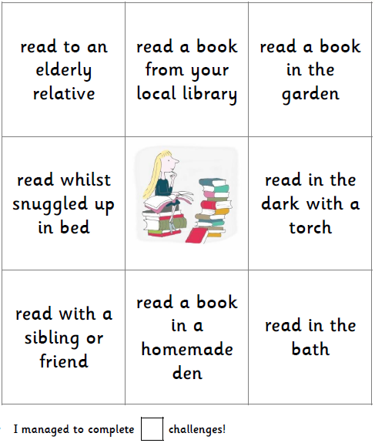

read a picture book

read with a family member

Here is a photograph of me completing one of the Reading Challenge tasks:

In this photo, I am reading (parent to write response)
______________________________________________________________ _______________________________________
I enjoyed this task because (parent to write response)
_______________________________________________________________________________

Make sure you get whoever you read with to comment in your reading journal about which task you have completed and how excellent your reading is!

Year 2 Reading Challenge!
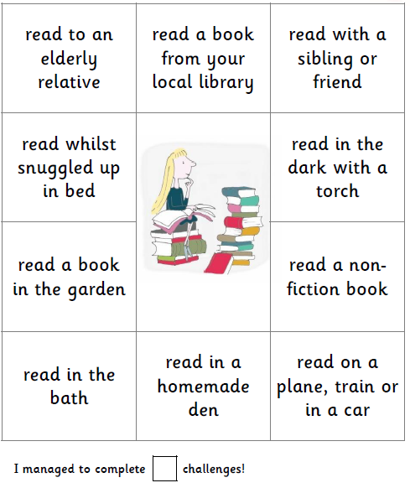
Over the holidays, try to complete at least 2 of these reading challenges as possible. Tick and date the ones you have completed, and return to your new class teacher after half term.
.

read with a family member

read a picture book

read on the move! A car, bus or train

Here is a photograph of me completing one of the Reading Challenge tasks:

In this photo, I am reading ______________________________________________________________ by _______________________________________.
I enjoyed this task because _______________________________________________________________________________.

Make sure you get whoever you read with to comment in your reading journal about which task you have completed and how excellent your reading is!

Year 3 Reading Challenge!
Over the holidays, try to complete as many of these reading challenges as possible. Tick and date the ones you have completed, and return to your new class teacher after half term.
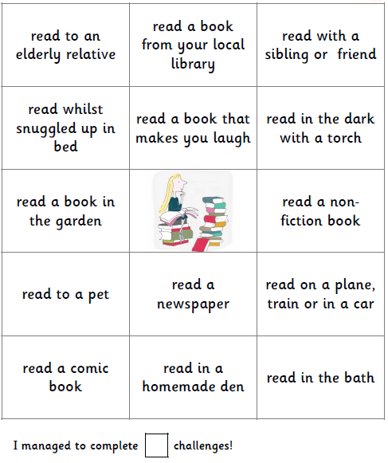

read with a family member

read a picture book

read on the move! A car, bus or train

Here is a photograph of me completing one of the Reading Challenge tasks:

Tell us:
- What you are reading.
- Why you chose that book to read.
- Did you enjoy this book?
- Why did you choose to photograph this task? Was it exciting? Was it your favourite?
__________________________________________________________________________________________________________________________________________________________________________________________________________________________________________________________________________________________
______________________________________________________________________________________________

Make sure you get whoever you read with to comment in your reading journal about which task you have completed and how excellent your reading is!

Year 4 Reading Challenge!
Over the holidays, try to complete as many of these reading challenges as possible. Tick and date the ones you have completed, and return to your new class teacher after half term.
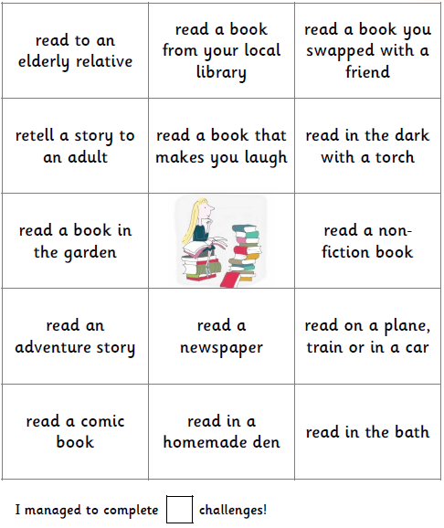

read a picture book

read a selection of poems

read on the move! A car, bus or train

Here is a photograph of me completing one of the Reading Challenge tasks:

Tell us:
- What you are reading.
- Why you chose that book to read.
- Did you enjoy this book?
- Why did you choose to photograph this task? Was it exciting? Was it your favourite?
__________________________________________________________________________________________________________________________________________________________________________________________________________________________________________________________________________________________
______________________________________________________________________________________________

Make sure you get whoever you read with to comment in your reading journal about which task you have completed and how excellent your reading is!

Year 5 Reading Challenge!
Over the holidays, try to complete as many of these reading challenges as possible. Tick and date the ones you have completed, and return to your new class teacher after half term.
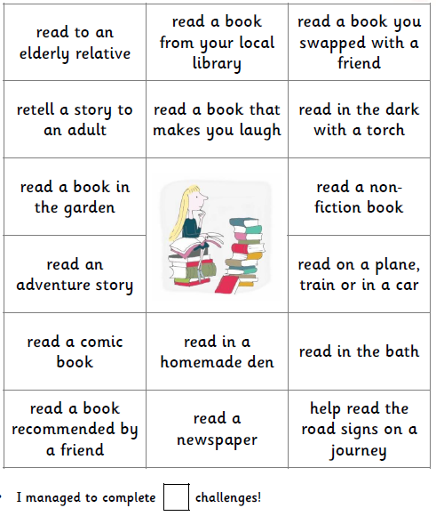

read a selection of poems

read a picture book

read on the move! A car, bus or train

Here is a photograph of me completing one of the Reading Challenge tasks:

Tell us:
- What you are reading.
- Why you chose that book to read.
- Did you enjoy this book?
- Why did you choose to photograph this task? Was it exciting? Was it your favourite?
- Would you recommend this book to a friend in your class? Explain why.
__________________________________________________________________________________________________________________________________________________________________________________________________________________________________________________________________________________________
______________________________________________________________________________________________

Make sure you get whoever you read with to comment in your reading journal about which task you have completed and how excellent your reading is!

Year 6 Reading Challenge!
Over the holidays, try to complete as many of these reading challenges as possible. Tick and date the ones you have completed, and return to your new class teacher after half term.
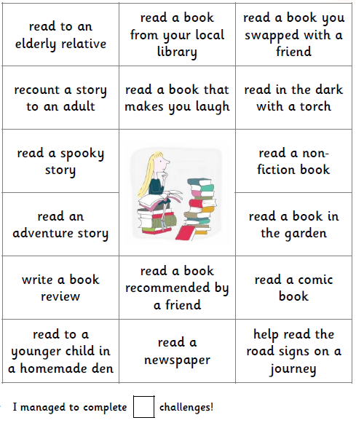

read a selection of poems

read a picture book

read on the move! A car, bus or train

Here is a photograph of me completing one of the Reading Challenge tasks:

Tell us:
- What you are reading.
- Why you chose that book to read.
- Did you enjoy this book?
- Why did you choose to photograph this task? Was it exciting? Was it your favourite?
- Would you recommend this book to a friend in your class? Explain why.
__________________________________________________________________________________________________________________________________________________________________________________________________________________________________________________________________________________________
______________________________________________________________________________________________

Make sure you get whoever you read with to comment in your reading journal about which task you have completed and how excellent your reading is!

