Year 2 Reading Challenge!
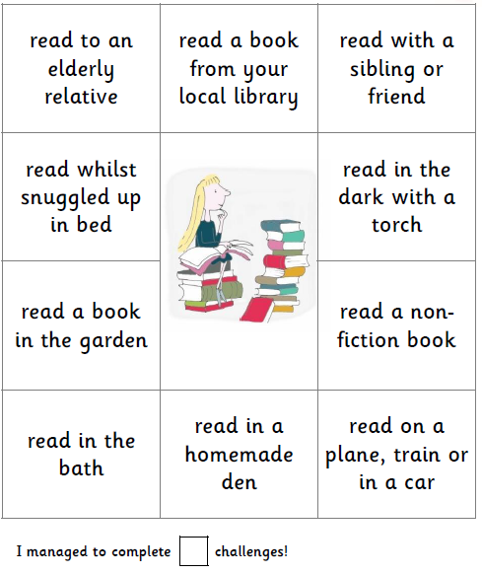
Over the holidays, try to complete as many of the reading challenges as you can. Tick and date the ones you have completed, and return to your class teacher after the holidays.
.

read with a family member

read a picture book

read on the move! A car, bus or train

Here is a photograph of me completing one of the Reading Challenge tasks:

In this photo, I am reading ______________________________________________________________ by _______________________________________.
I enjoyed this task because _______________________________________________________________________________.

Make sure you get whoever you read with to comment in your reading journal about which task you have completed and how excellent your reading is!

