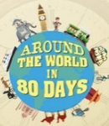
Around the World in 80 days
Write down and learn your full address. Be ready to recite it before looking!  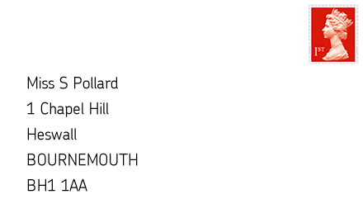  (2 points) | What would it sound like if you talked to someone from Spain? Write down some Spanish words and their meaning.  (3 points) | Make a model vehicle. It can be any type of vehicle that interests you. The more interesting it is the better it will be.  (3 points)
Imagine you are looking down from a hot air balloon high in the sky. Create a collage showing all the things you can see. You can use different types of paper, cut out images from magazines, paint etc. (4 points) | 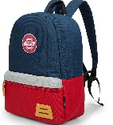  Pick ten things you would pack for a journey around the world. Explain why you would select each of the items. (3 points) | Detective Fix uses ‘Wanted’ posters to catch Phileas Fogg. See if you can create a ‘Wanted’ poster for either a friend or a member of your family. Remember to draw a picture and a written description!  (3 points)
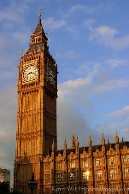  Draw a famous landmark in the United Kingdom. (3 points) | Interview a friend or family member who has visited another city or country. What did they like about it? What didn’t they like about it?  (3 points) | Make a sketch of the Eiffel Tower.  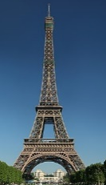  (2 points).
What would you eat if you went on holiday to India? Can you write what you would eat?  (2 points) | Learn the capital cities of the UK.  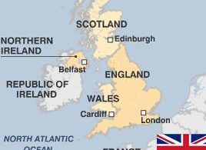  (3 points) | Have fun completing these activities. Over the next half term please try to complete at least 1 challenge per week.  It is entirely up to the children which activities they pick. All homework to be handed in by Monday 4th April 2022.
Homework Menu
Bronze certificate - 11 points Silver certificate - 18 points Gold Certificate - 25 points

