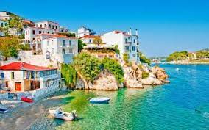  Make a collage using pictures from holiday brochures or the internet showing ancient buildings and interesting place to visit in Greece. | Learn a poem to recite to the class that has a Greek theme or is based on a fable/myth. | Find out about the Greek alphabet and present your findings in an exciting way.  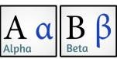 | Who was Pythagoras? How is he linked to maths? What is  Pythagoras’ theory? Present your findings – use diagrams to explain what you have learnt.  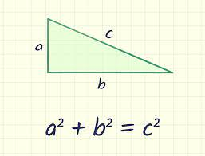
Make an A-Z of Greece. Think about presenting your work in the best way possible. What could you do on the border? You could add an illustration to each or some of the letters along with small pictures linked to your sentences. | Design and make your own Labyrinth. It could be made of straws, string or wood.  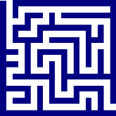 | Create a picture of an imaginary Greek God. Make sure your poster is eye-catching and full of facts and information. Try to think of a symbol for your God. | Find out what life was like for children in Ancient Greece. How will you present your information?  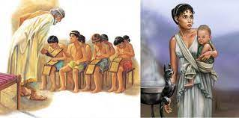
Make a Spartan helmet or design a shield.  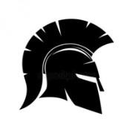 | 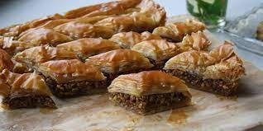  Cook some Greek food or a meal. Write up the recipes. Can you include a photo of your creation too? | Find out some simple Greek phrases. E.g Hello, How are you? What’s your name? etc. Can you make a poster to display them in Greek and English?  If you can learn the pronunciation, can you try and teach us at school? | Write an advert persuading people  to visit the ancient Olympic Games. 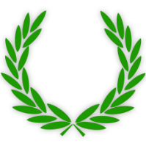
A copy of this grid is on our class page on the school’s website.

