Holiday Activity

Next half term’s special book is
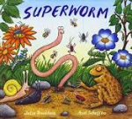

Find a worm and watch how it moves.
Can you wiggle and squirm like a worm?

