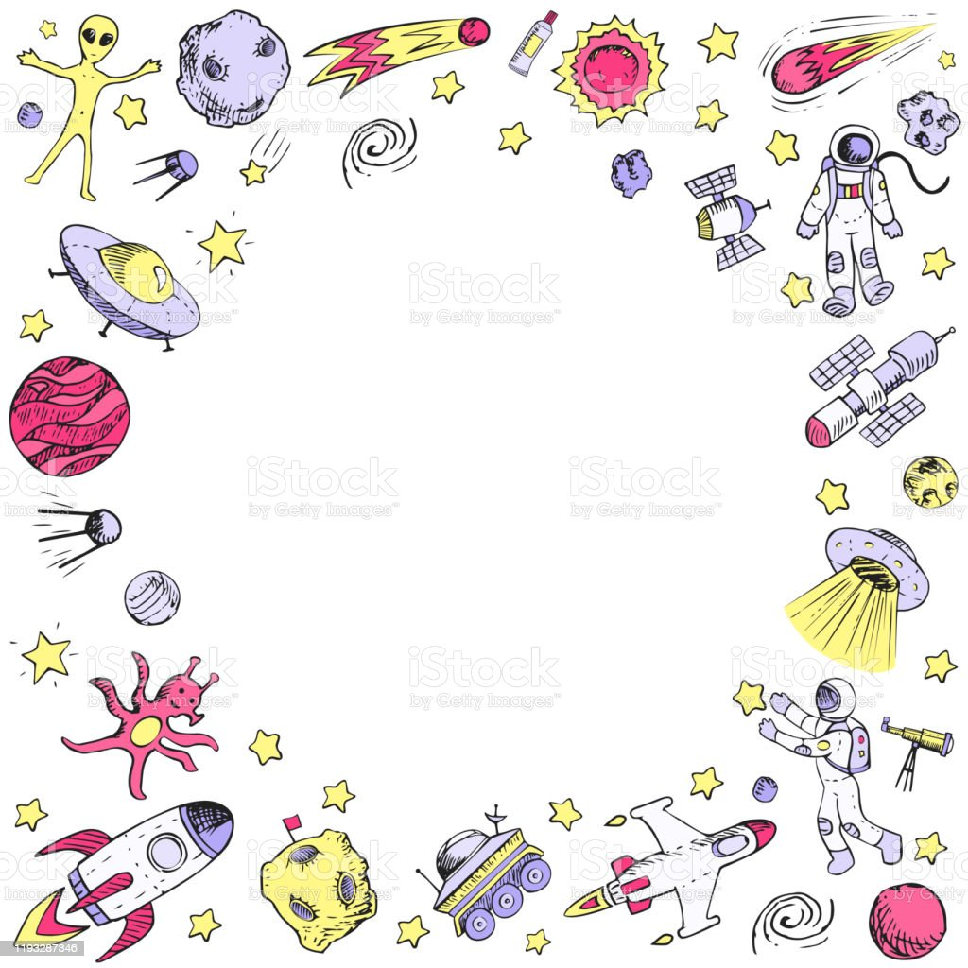

Reception Holiday Homework

I wonder what’s out there?

Next term we will be reading the book Aliens Love Underpants. Ask your child to design and create their own alien. Use the following questions to prompt discussion with your child.

What is an alien? What do they look like? Where do they come from?

We hope your holiday is out of this world!