YEAR 6 HOLIDAY HOMEWORK
DUE IN 6th September 2022
 | History topic homework  Next term our topic will be World War II and we will be focusing in particular on the Battle of Britain (1994). To kick start our topic, we would like you to complete one of the following  - Talk to someone who remembers the war or anyone who fought in the war.  - Research– James Harry Lacey (Ginger).  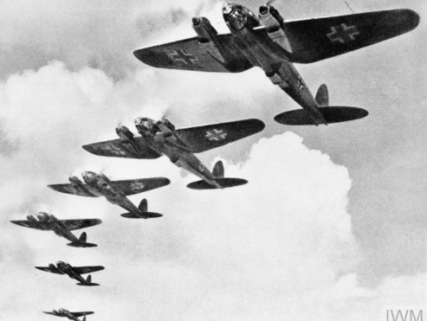  Be prepared to share your ideas with your class teacher when you return back! | Maths  Lots of Times Table Rock Stars to prepare us for September.  Practise your Key Instant Recall Facts  