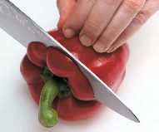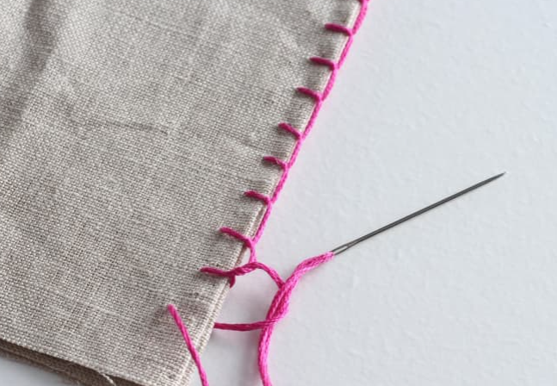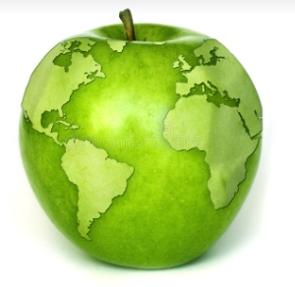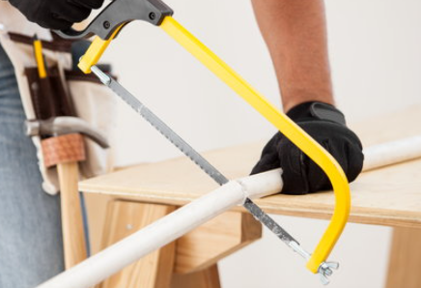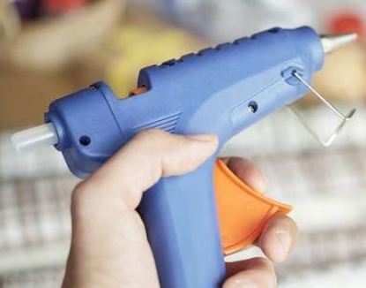
Design Technology at Wibsey Primary School
"Design is not a single object or dimension. Design is messy and complex."
Natasha Jen, designer and educator
Design Technology Intent
At Wibsey Primary School, the overarching intent of our Design Technology curriculum is to develop a creative mind, flourish the imagination and to design and make products within a variety of contexts. Our curriculum has been carefully designed so that it is engaging, providing breadth, depth and access to the full curriculum for every pupil.

Design and technology is an inspiring, rigorous and practical subject. Using creativity and imagination, pupils design and make products that solve real and relevant problems within a variety of contexts, considering both their own and others’ needs, wants and values. They acquire a broad range of subject knowledge and draw on disciplines such as mathematics, science, engineering, computing and art.

As pupils progress through Wibsey Primary School, they use their creativity and imagination to design and make products within a variety of contexts. They learn how to take risks, become resourceful and innovative and evaluate past and present designs which, in turn supports pupils in developing a critical understanding of design impact on daily life and the wider world. With high-quality design and technology education, children will be able to contribute through creativity.

We are committed to developing our children as designers; children will have the opportunity to use a variety of different equipment in order to follow ambitious design plans. They answer evaluation questions on their products and change their designs throughout to make sure they meet the needs of their target audience. Throughout our design, make, evaluate model the children have the opportunity to stretch their vocabulary and reflect at all stages on the product they are creating. Throughout the design technology curriculum, the children will also have the opportunity to develops the skills and confidence appropriate to manipulating a wide range of materials, tools and the economic management of resources.

It is vital that children understand and have a greater awareness of how design technology has shaped the products we use every day and the physical world around us. It is through their understanding of existing products, and the design making process, that our children will better understand the development of new products within the world today. Our design technology curriculum will enable our children to gain a coherent knowledge and understanding of nutrition and a healthy lifestyle, in addition to developing skills in food preparation. It is our intent that pupils leave Wibsey feeling proud of their accomplishments and are able to use their new learnt skills later on in their learning journeys into society.

Implementation – How we plan and teach Design Technology
The Design Technology Cumulative Curriculum ensures that all pupils develop the creative, technical and practical expertise needed to perform everyday tasks and ensure that they participate successfully in an increasing technological world around them.

Children will be taught to build and apply a repertoire of knowledge, understanding and appropriate skills in order to design and make high-quality prototypes and products for a wide range of users. They will critique, evaluate and test materials, ideas and products and develop and use subject specific vocabulary. Our curriculum allows the children to work collaboratively with others and throughout our cooking curriculum the children will be able understand and apply the principles of nutrition.

The cumulative curriculum identifies the progressive development of skills, knowledge and conceptual understanding that pupils will progressively develop across school. These skills are tailored to the themes which are outlined in the Long-Term Plan. Across school children are given the opportunity to revisit and develop the skills taught as well as being given the opportunity to challenge and deepen their understanding.

In foundation stage the children develop their knowledge and skills of a variety of materials, tools and techniques through exploration; both independent and adult-led. These early experiences include asking questions about how things work, investigating and using a variety of construction kits, materials, tools and products, developing making skills and handling appropriate tools and construction material safely and with increasing control. These experiences attract the children’s interest and curiosity, help them to make sense of their world and form the foundations for later work in Design and Technology.

Children are encouraged to share their creations and talk about the processes and strategies they used to reach the final product.

Within Key Stage 1 and 2 children will be taught, through a variety of creative and practical activities, the knowledge, understanding and skills needed in an iterative process of designing and making. Children will learn how to design, make, evaluate and use technical knowledge and vocabulary. They will be taught to use a range of materials including construction, textiles and ingredients.

In Key Stage 1, pupils will be taught how to use mechanisms in products. In Key Stage 2, pupils will be taught how to use mechanical and electrical systems in their products and use computer programming to monitor and control products.

Children should work in a range of relevant contexts, such as the home, school, gardens and the outside provisions.

When designing and making, pupils are taught to design purposeful, functional, appealing products for themselves and other users based on design criteria which are increasingly fit for purpose and aimed at particular individuals or groups.

In Key Stage 1 children generate, develop, model and communicate their ideas through talking, drawing, templates, mock-ups and, where appropriate, information and communication technology. In addition, at Key Stage 2 children use annotated sketches, cross-sectional and exploded diagrams, prototypes, pattern pieces and computer-aided design.

Across school children select from and use an increasingly wider range of tools and equipment to perform practical tasks, such as cutting, shaping, joining and finishing. Children will select, with increasing accuracy, from and use an increasingly wider range of materials and components, including construction materials, textiles and ingredients, according to their characteristics, functional properties and aesthetic qualities.

Within Key Stage 1, children will be able to explore and evaluate a range of existing products, evaluate their ideas and products against a design-criteria that they have followed and adapted themselves.

Within Key Stage 2 pupils will be working with their own design criteria and will consider the views of others to improve their work. They will also develop an understanding of how key events and individuals in design and technology have helped shape the world around them.

As part of their work with food, children are taught how to cook and apply the principles of nutrition and a healthy and varied diet to prepare and cook dishes using a range of cooking techniques. Learning how to cook is a crucial life skill that enables them to feed themselves and others affordably and well, now and in later life.

By the end of Key stage 1 the children will have the opportunity to acquire skills to help them handle kitchen utensils safely and appropriately. The children will use suitable equipment to peel, slice and chunk a variety of different ingredients.

By the end of Key Stage 2, the children will have the skills to use a wider range of tools safely and accurately in order to meet the skills such as chopping, frying, measuring and combining. They will have the opportunity to use a wider variety of equipment such as knives, hot pans, hobs and the ovens to create a variety of different dishes following health and safety procedures. They will understand seasonality and how this affects the food available as well as where our food comes from and how it is processed and safely transported around the world.

Impact – How difference does the Design Technology curriculum make to our children?
Through the high quality first teaching of Design Technology we will see the impact in different ways. Primarily, children will design and create products that meet a given design criterion. The children will acquire a range of skills by drawing upon their knowledge of tools, materials and techniques to select and use them appropriately.

Pupils will gain a clear knowledge and understanding of research when designing and creating products. They will collect data and create a product that is informed by their research and responses to interviews and questionnaires.
Children will have the opportunity to create pupil interviews, have a pupil voice and in particular relating to pupil’s enjoyment, satisfaction and purpose in designing and making things and understanding how it works.

Work will show that a range of topics is covered across school, cross curricular links are made where possible and differentiated work set as appropriate, including support where physical difficulties make the use of tools difficult. The progressive development of designing, making and evaluating skills will be evident alongside finished products that become more refined, functional and aesthetically appealing.

Assessments and monitoring will evidence the school’s aspiration for high standards in Design Technology; attainment will be high and match standards in other subject areas.

