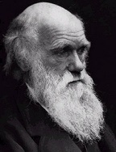
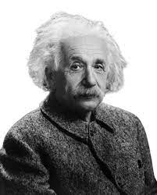
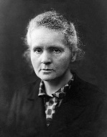

Science at Wibsey Primary School
‘Nothing in life is to be feared. It is only to be understood.’
Marie Curie
Science Intent
At Wibsey Primary School, the intent of our science curriculum is to develop children’s curiosity, enthusiasm and interest in science. Our science curriculum is designed to equip children with the knowledge, skills and core learning experiences so that they are able to make sense of the world in which they live and which prepares them for life in an increasingly scientific and technological world. We intend to deliver a science curriculum which develops enquiry-based learning and results in the acquisition of knowledge.

We believe that a broad and balanced science curriculum will allow children to gain a coherent knowledge and understanding of the three main strands of science; biology, chemistry and physics. Scientific enquiry skills are embedded and interwoven throughout the scientific topics that children study. Some topics are revisited in later years which allows children to build upon prior knowledge and deepen their understanding. In science lessons, children are encouraged to use a range of skills including questioning, planning, observing, testing and evaluating. It is our intent that children leave Wibsey Primary School with a well-rounded education in science so that they are able to excel in future learning.

Implementation – How we plan and teach Science
At Wibsey Primary School, Science is taught as an integral part of the ‘Wibsey Cumulative Curriculum’ with appropriate subject knowledge, skills and understanding as set out in the National Curriculum Science Programmes of Study. We have a coherently planned and sequenced curriculum which has been carefully designed with the need of every child at the centre of what we do. Sequential teaching provides opportunities for children to build upon prior learning and embed key scientific concepts. The knowledge and skills that children will develop throughout each science unit are mapped out across each year group and across the school to ensure progression.

Children begin in the Early Years by exploring and making observations about the world around them. In Key Stage One, children begin to understand basic scientific principles and carry out simple investigations using the five types of scientific enquiry. In Key Stage Two, children learn how to develop a scientific approach to testing ideas, finding evidence and investigating scientific phenomena. As they progress across school, children become more proficient in selecting, using scientific equipment, collating and interpreting results, and they become increasingly confident in their growing ability to reach conclusions based on real evidence. We enrich our science curriculum by providing additional opportunities for children to enhance their learning experiences through whole-school events such as ‘Science Week’ and educational visits linked to the science curriculum.

School is working towards providing all children with a knowledge organiser at the start of each science unit. This will support learning and the retention of knowledge, as well as the acquisition of the key scientific vocabulary that is relevant to the unit being taught. This is not used as part of assessment, but to support children with their acquisition of knowledge and as a point of reference throughout the unit. Key scientific language is modelled and taught throughout lessons, enabling children to become familiar with and internalise subject specific vocabulary. Working walls are a key feature of the learning journey and show how knowledge, skills and vocabulary is built up over the course of a unit.

Impact – What difference does the Science curriculum make to our children?
The impact of our science curriculum will lead to children who are engaged in their learning, have an inquisitive mind and want to find out more. The overall ambition for our children is that they are able to speak confidently about science and make links with, and better understand, the real world. We aim to provide children with the foundations on which they can build on their existing scientific knowledge and skills, ensuring that they are prepared for the next stage of their education.

Children will understand, through the study of significant people, that science has changed our lives and that it is vital to the world’s future prosperity.

