Year 3 Holiday Homework
Reading Challenge
Over the holidays, try to complete as many of these reading challenges as possible. Bring evidence of any kind (e.g. pictures) to show us your fabulous attempts at these challenges.
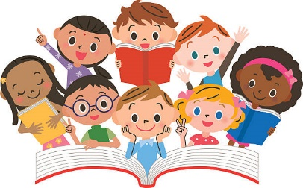
Read a picture book. | Read a book in an interesting place. | Read with a family member.
Read whilst in bed. | Read a book that makes you laugh. | Read in the dark with a torch.
Read a book in the garden. | Read a book upside down. | Read a non-fiction book.
Read to a pet. | Read a newspaper. | Read a fiction book.
Read a comic book. | Read in a homemade den. | Read in fancy dress.

Next half term we will be learning about the Stone Age to the Iron Age.
Our learning challenge question is:
How did life change between the Stone Age and Iron Age?
Your challenge this holiday is:
To research Skara Brae.
What is it? Find out all about it!
Present your findings in any way you choose. Investigate a few key words or you might want to create a poster or a fact file - be as creative as you can!
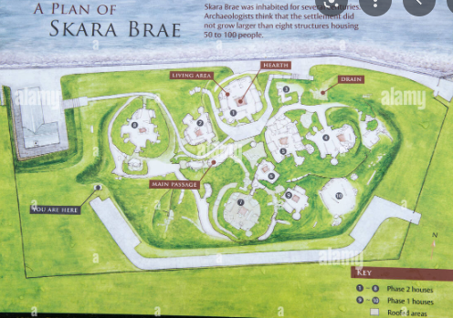
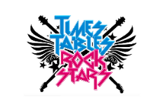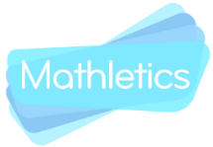
Please remember to continue working on Mathletics, Times Tables Rockstars. We will be handing out certificates achieved in our honours assembly on the first Friday back. The TTRS tournaments will continue to run throughout the holidays!
Have a lovely, relaxing break!
Mrs Gallucci, Mrs Davies and Mrs Bilevvych

