Dear Parents / Carers,

Happy half term!

It has been a busy half term where we have been working really hard! Our curriculum in November and December will be based around the text ‘Goodnight Mr Tom’. In English, we will be focusing a lot of our reading and writing around the novel. During maths lessons, we are focusing on fractions, decimals and percentages. Our Prime Learning Challenge for next half term will be ‘How WWII affected the lives of people at home?’ This will be a History led theme. In Science, we are looking at electricity, while in Computing we will be learning all about online safety. Through art we will be creating sculptures.
PE days
Please find the P.E dates for your child’s class below:
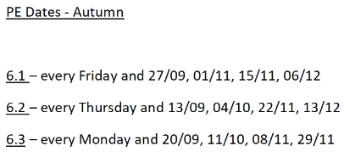

A polite reminder to please ensure that your child comes to school in their PE kit on their designated day. Children can wear their Wibsey jumper, a white T- shirt, black shorts and trainers. If the weather is cold the children can wear dark, plain jogging bottoms (not leggings) as PE will most likely take place outside. Please note that ear rings should not be worn for PE and should be removed for the day prior to leaving home or tape applied. Long hair should be tied back.
To be clear, it is ok to wear PE kit to school on PE days so no changing takes place.

Reading and Spelling
Your child will be given a reading book and a reading journal to bring home and read (for at least 15 minutes every day). They will need to keep their reading journal and book in their book bags to bring to school every day. As book bags will be kept in the classroom, children cannot use large bags or rucksacks. Spellings are sent home weekly for your child to practise and learn.

Water Bottles and Lunch Boxes
Children need to bring in a named water bottle into school every day. If they are not having a school lunch and are bringing their own in from home, we encourage this to be in a disposable bag or a small lunch box which can be wiped down easily. Water bottles and lunch will be kept in the classroom under their chairs.

Homework
Homework is an opportunity for you to share in your child’s learning, by supporting and encouraging them as they complete their homework tasks. The children will be able to choose to do homework in any order from the homework menu. While it should be primarily their work, please feel free to help them with any parts they find more challenging. Homework will usually be set on a Wednesday and due in on a Tuesday.

Thank you for your continued support.
Year 6 staff.

