Wibsey Primary School
North Road, Bradford, BD6 1RL
Tel: 01274 678016/775545
Headteacher: Mr N M Cooper

20.10.22
Murton Park fieldwork

Dear Parent/Carer,
As part of our History work on World War Two, we are pleased to confirm that we plan to take Year 6 children to Murton Park (York) on the following dates:
Friday 2nd December 2022 – Class 6.1
Wednesday 7th December 2022 – Class 6.2
Friday 9th December 2022 – Class 6.3

The visit will provide an insight into the life of an evacuee in the early days of the Second World War. The day is a mixture of talks, demonstrations, and hands-on activities. The children will hear from an evacuation co-ordinator about the process of evacuation and what to do during an air raid. All visits are thoroughly risk assessed by the venue and school.
Your child will need to bring a packed lunch with them. If your child is entitled to free school meals this will provided by school, however please provide a drink in a water bottle. No glass bottles or fizzy drinks please.

To add to the experience, we ask that children come to school in period clothing. For example, this can be trousers and a shirt with a jumper or waistcoat over (please see imaged attached for reference.) Please ensure that your child has a coat and comes in appropriate footwear for the occasion.

On the day of the visit, we will be leaving school at 9:00 am and travelling by minibus. We will arrive back at school for approximately 4:15pm. Please collect your child from the playground in the usual way.
At Wibsey Primary School we are committed to supporting families where we can with the cost-of-living crisis. We are pleased to inform you that this trip has been fully subsidised by the school at a cost to us of £15.50 per pupil. This means there will be no cost for you to pay on this occasion.
In order to confirm the booking and finalise arrangements, please complete the attached slip and return directly to your child’s class teacher by Friday 4th November 2022 at the latest.
With thanks for your continued support.

Mr Lugg, Miss Yaqub and Miss Chaudhry
Year 6 Class Teachers
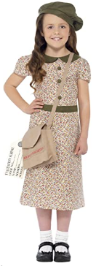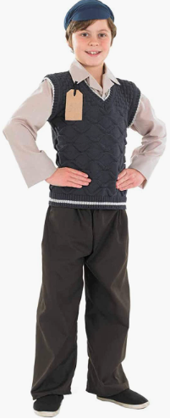

Murton Park Visit Permission Slip – Year 6

Child’s Name ………………………………………………………………………. Class …………………

I wish my child to visit Murton Park on the relevant date.

Signed ……………………………………………………………………………… Date ………………….
Parent/Carer

