**At home, can you write down ways that you have used your learning muscles?**

**At home I have used my Capitalising learning muscle to:**

**..............................................................**

**..............................................................**

**..............................................................**



**At home I have used my Planning learning muscle to:**

**..............................................................**

**...............................................................**



**At home I have used my Revising  
learning muscle to:**

**..............................................................**

**...............................................................**





**Which learning muscles will**

**your child use in Year 3?**

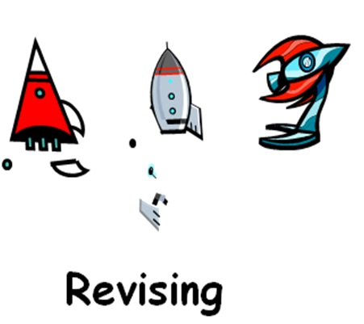

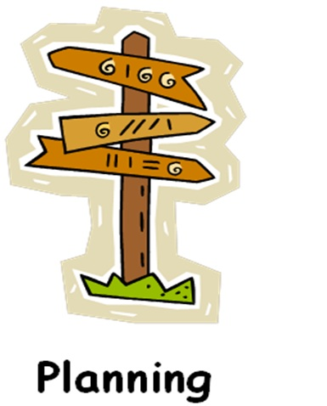



**We use our ‘Capitalising’ learning muscle to help us use a variety of resources available to help us.**

**For example, in class we use our Capitalising muscle to:**

* **Ensure that we have all the equipment needed to complete a task.**
* **Know where in our classroom we can find further information.**
* **Know when to work alone or in a group.**



**We use our ‘Planning’ learning muscle to help us to understand what the task is and ensure we include enough detail.**

**For example, in class we use our Planning muscle to:**

* **Know what the next steps are to help us in our learning.**
* **Check that we have included enough detail in our work.**
* **Know exactly what I have to do for each step of my learning.**

**For example, in class we use our Planning muscle to:**

* **Use the Super Learner Steps for our task.**
* **Know what the next steps are.**
* **Know exactly what I have to do for each step.**

**For example, in class we use our Planning muscle to:**

* **Use the Super Learner Steps for our task.**
* **Know what the next steps are.**
* **Know exactly what I have to do for each step.**



**For example, in class we use our Planning muscle to:**

* **Use the Super Learner Steps for our task.**
* **Know what the next steps are.**
* **Know exactly what I have to do for each step.**

**We use our ‘Revising’ learning muscle to help us to check our goals and change direction if we need to.**

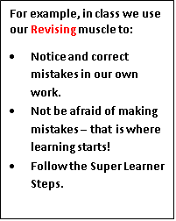

**For example, in class we use our Revising muscle to:**

* **Notice and correct mistakes in our own work.**
* **Not be afraid of making mistakes – that is where learning starts!**
* **Follow the Super Learner Steps.**



**For example, in class we use our Revising muscle to:**

* **Notice and correct mistakes in our own work.**
* **Not be afraid of making mistakes – that is where learning starts!**
* **Follow the Super Learner Steps.**

**Can you help your child to use their learning muscles at home?**

**Let them find answers to questions by themselves by drawing on resources available to them.**

**Can a route be planned, using a map on a phone, to walk into Bradford town centre? How about helping to write a shopping list to plan a meal?**

**Encourage your child to attempt something new and not be afraid to make mistakes.**





