At home, write down ways that you have used your learning muscles.
At home I have used my Distilling learning muscle to:

..............................................................

..............................................................

……………………………………………………………..

..............................................................

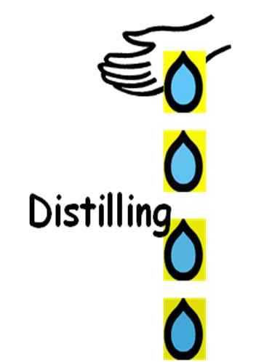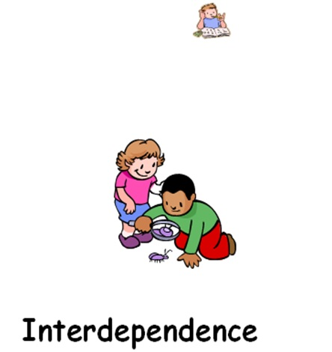

At home I have used my Meta-learning learning muscle to:

..............................................................

...............................................................

……………………………………………………………...

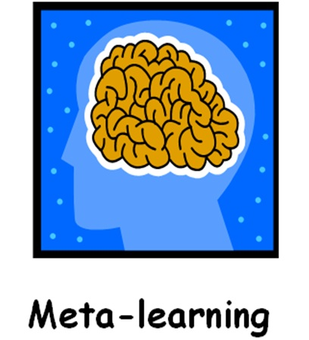

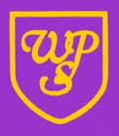
Which learning muscles will
your child use in Year 5?

We use our ‘Distilling’ learning muscle to help us separate key information and place new acquired knowledge to a variety of subjects and situations.
For example, in class we use our Distilling muscle to:
- ................................

- ................................

- ................................

We use our ‘Meta-learning’ learning muscle to think about how we have done something and reflect on what worked well and what we could do next time.
For example, in class we use our Meta-learning muscle to:
- ................................

- ................................

- ................................

Can you help your child to use their learning muscles at home?
Can your child summarise their favourite lesson from the day? Can your child tell you any new learning from this half term/Year 5 so far?
...............................................................................
...............................................................................
When your child is completing their homework ask them what went well? What could they use again to help them?

..............................................................................
..............................................................................

