At home, write down ways that you have used your learning muscles.
At home I have used my Interdependence learning muscle to:

..............................................................

..............................................................

……………………………………………………………..

..............................................................

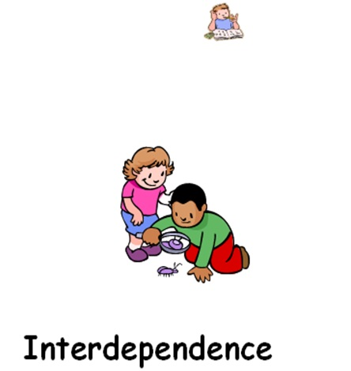

At home I have used my Meta-learning learning muscle to:

..............................................................

...............................................................

……………………………………………………………...

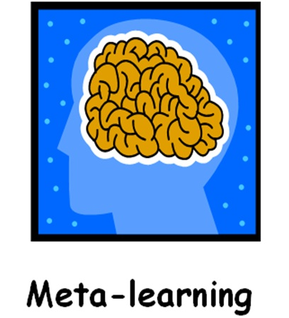

Which learning muscles will
your child use in Year 6?

We use our ‘Interdependence’ learning muscle to help us to know that we are responsible for our own learning and to enjoy learning with others.
For example, in class we use our Interdependence muscle to:
- ................................

- ................................

- ................................

We use our ‘Meta-learning’ learning muscle to reflect on our previous experiences and use successful experiences to learn more.
For example, in class we use our Meta-learning muscle to:
- ................................

- ................................

- ................................

Can you help your child to use their learning muscles at home?
What learning behaviours and skills has your child imitated? How could they be a good role model during class and at home?
...............................................................................
...............................................................................
When your child is completing their homework, ask them ‘What worked well that you could use again?’.
Ask them to think of a positive/successful experience at school. How could this help them to learn further?
..............................................................................
..............................................................................

