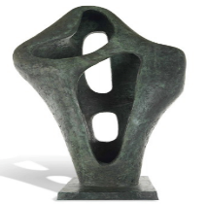
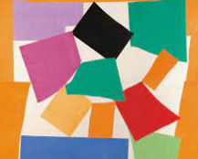
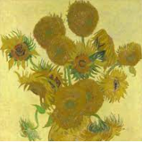
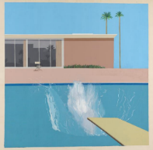
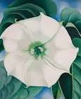

Art and Design at Wibsey Primary School
“Creativity is intelligence having fun”
Albert Einstein
What our children learn in Art and Design (Intent)
At Wibsey Primary School we see Art and Design as an important part of the children’s entitlement to a broad and balanced curriculum. We believe that Art allows children to explore, build on and record their own creative and imaginative ideas. Creativity allows children to express their feelings and ideas, both as a means of self-expression and to communicate to others.

Children will​ become proficient in drawing, painting, sculpture, printing and collage techniques. They will use a wide range of media and materials, learning how to use these with increasing control and technique as they progress through school.

In each year group children will look at the works of a range of artists both past and present, developing an appreciation for their work. By year 6 they will have knowledge of a range of local, national and international artists. They will evaluate and analyse creative works using the language of art, craft and design. We believe learning about a range of artists will motivate and inspire children in their own work and help them appreciate art’s role in society and its contribution to the culture and creativity of the nation.

Through Art and Design we want children to develop their imagination and creativity; to make connections through their inventive minds and give them the skills to record their creative ideas. To enable them to do this, children use these sketchbooks to gather ideas, record ideas, practise skills and then review and revisit ideas to improve their mastery of art and design techniques. Displaying and showcasing their work on the Art Gallery enables children to create artwork with a real purpose.

How our children learn in Art & Design (Implementation)
At Wibsey Primary School, Art and Design is taught as an integral part of the ‘Wibsey Cumulative Curriculum’ and we provide an art curriculum with appropriate subject knowledge, skills and understanding as set out in the National Curriculum Art and Design Programmes of Study. The overall ambition for our children is that they develop a wide range of artistic skills and are exposed to the works of a range of artists, craft makers and designers. The key elements of art are integral to children’s understanding and are developed from the foundation stage up to year 6. These key elements are line, shape, form, tone, texture, pattern and colour, they are taught and explored in drawing, painting, sculpture, printing and collage.

In the foundation stage we relate the creative development of the children to the objectives set out in the Early Learning Goals, which underpin the curriculum planning for children aged three to five. We provide a rich environment in which we encourage and value creativity. Children experiment with colour, textures and a variety of materials. They experience a wide range of activities that require imaginative thought, they explore using their various senses, develop their own ideas and select their own resources. Children are encouraged to create on both small and large scales and our outdoor environment supports this well.

In Key stage one children are taught to use a range of media to explore and create their own pieces of art work. They practise and develop their skills in drawing, painting sculpture, printing and collage. They develop techniques in using colour, pattern, texture, line, shape, form and space. They begin to use sketchbooks; these provide a ‘safe place’ where children can explore different techniques and ideas and practise skills. They learn about the work of a range of artists, craftsmen and designers, describing the differences and similarities between different practices and disciplines, and making links to their own work.

In Key stage two children are taught to develop their techniques, including their control and their use of materials, with experimentation and an increasing awareness of different kinds of art, craft and design. They develop their use of sketch books to record their observations and use them to review and revisit ideas, and collect visual material to help them to develop their ideas. Children improve their mastery of techniques in drawing, painting sculpture, printing and collage, learning how to add detail to their drawing, using different resources to create texture and printing as well as using tools to carve and create and add pattern to sculpture.

Across school, children will be exposed to different art styles by artists from different cultures, genres and races, as well as architects and designers in history.
We believe learning about a range of artists, craftsmen and designers will motivate and inspire children in their own work and help them appreciate art’s role in society.

Children will have opportunity to reflect on, and evaluate their work, and to respond to their peers and artist’s work. They will use key art terminology and vocabulary such as colour, tone, pattern, texture, line, shape and form.

What difference does the Art and Design curriculum make to our children? (Impact)
Through the high quality first teaching of Art we will see the impact in different ways. Primarily, children will be engaged in their learning in Art, develop as artists and be enthusiastic in their acquisition of new artistic skills and techniques. It will contribute to their personal development in creativity, independence, judgement and self-reflection. Pupils will gain a coherent knowledge and understanding of the key elements of art- line, shape, form, tone, texture, pattern and colour.

Final pieces of art work and sketchbooks will evidence that a range of skills and techniques have been progressively taught, that a range of artists, designers and craft makers have been explored and that children have applied their skills to a wide range of final pieces. Assessments and monitoring will show standards in Art will be high and will match standards in other subject areas.

