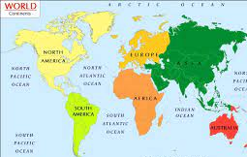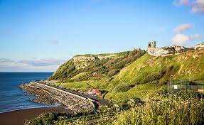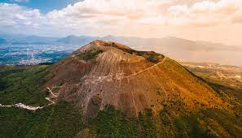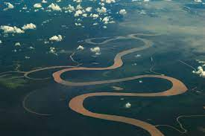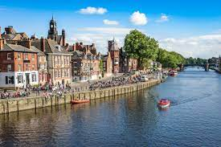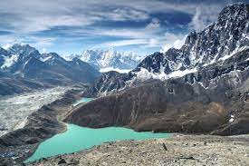
Geography at Wibsey Primary School
“Geography is a living, breathing subject, constantly adapting itself to change. It is dynamic and relevant. Geography is a great adventure with a purpose, it is a subject which holds the key to our future.”
Sir Michael Palin, president of the British Geographers, 2010
What our children learn in Geography (Intent)
At Wibsey Primary School, the intent of our geography curriculum is to inspire children’s curiosity, interest and appreciation for the world in which we live, and to provide our children with a means of exploring, appreciating and understanding of the physical and human aspects of the world. Geography is an investigative subject, and our curriculum is designed to provoke and provide answers to questions about the natural and human aspects of the world. Through the cumulative development of children’s previous learning, our children are provided with the necessary skills and knowledge to become geographers, and with progression across school children develop a greater understanding and knowledge of the world, as well as their place and significance in it.

It is important that our children understand the relationship between the earth and its people. Children learn about the uniqueness of diverse places and environments and the geographical processes that shape and change landscapes and environments over time. Our geography curriculum enables our children to understand their rights and responsibilities towards the environment in which they live, they develop an understanding of the ways in which places are interdependent and interconnected and how much human and physical environments are interrelated. Geography is a subject which holds the key to our future, it is vital that our children have a deep understanding of the impact of human activity on the planet and understand their responsibility.

Fieldwork is an integral element of the geography curriculum. Children at Wibsey Primary are given real world opportunities to observe physical and human features, collect data and take measurements which can be used to make comparisons and draw conclusions. As pupils progress through school their growing knowledge about the world and fieldwork experience, helps to deepen their understanding of the interaction between physical and human processes. Children are taught about the human and physical features in their local area and how to locate them using a range of mapping skills. Learning wherever possible is linked to the local area, however, we believe that it is vital that all children are provided with a wider aspect of geography, to improve their understanding of the wider world around them.

Our geography curriculum provides children with knowledge about the world, the United Kingdom and their locality. Three main strands run throughout each unit of learning, these strands are intertwined and are therefore taught simultaneously. The first strand; developing geographical and fieldwork skills, is where children are taught to interpret a range of geographical information from different sources, such as maps, atlases and aerial photographs. The second strand, using geographical skills to enhance locational knowledge, involves children being taught how to use a range of globes and maps to locate a place and it’s human and physical features, within their local, national and global contexts. The third concept, developing conceptual knowledge of a place’s defining physical and human characteristics, is where children are taught about the geographical processes that change them over time and to identify the similarities and differences in human and physical geography, and recognise the interdependence of physical and human features.

We are committed to developing our children as geographers; for each unit of learning children answer geographical questions such as ‘How can we use the world’s resources responsibly?’ Studying geography in this way inspires children’s curiosity and fascination about the world and encourages them to ask critical questions. Children use their knowledge of the different geographical concepts to answer the learning challenge question, they draw on their previous learning and fieldwork experience to communicate their understanding effectively.

How our children learn in Geography (Implementation)
At Wibsey Primary School, geography is taught as an integral part of the ‘Wibsey Cumulative Curriculum’ and we provide a geography curriculum with appropriate subject knowledge, skills and understanding as set out in the National Curriculum Geography Programmes of Study. The overall ambition for our children is that they study a wide range of geography from local to global contexts, drawing on their knowledge of a place’s location and its human and physical features, through the development of geographical and fieldwork skills. Wibsey is ambitious in its coverage of geography and the sequential teaching of core skills and concepts deepens pupil’s understanding of the relations between the different fields in geography.

The geography curriculum is structured so that each year children have two or three half terms a year where geography is the subject driver for that term. Pupils answering a ‘Learning Challenge’ question such as ‘Where do rivers start and finish?’ guides the learning journey, with children acquiring knowledge and skills as they move towards drawing conclusions and explaining their findings when forming an answer to the question. Units of study have been selected from the National Curriculum to ensure that the children receive a high quality, deep and ambitious geographical learning experience. The knowledge and skills that children will develop throughout each geography topic are mapped across each year group and across the school to ensure progression.

The ambition of the geography curriculum, is for children to embed in an in-depth knowledge and understanding of the local area, the United Kingdom and other globally significant places, including their key topographical features and land use patterns. Children are taught how to locate countries, their main cities and their key physical and human features using a range of different globes, maps and atlases. Our geography curriculum aims to give children fieldwork opportunities where they can work geographically in a real-world setting. Pupils are taught how to interpret maps at different scales, diagrams and photographs; how to gather, analyse and evaluate information and data. It’s our ambition that children at Wibsey Primary School will use their knowledge to draw conclusions, identify relationships and provide detailed explanations. Our high-quality teaching of geography aims to promote the acquisition of language, geographical vocabulary and develops speech and language skills.

Each year group studies a number of geography driven learning units, each topic is inclusive of location and place knowledge, human and physical geography and geographical skills and fieldwork. Consideration has been given to ensure progression across geography topics across each year group and across school. Medium term planning details the sequential acquisition of subject knowledge and skills of each area of geography at an age appropriate level, this allows pupils to explore new information, develop geographical enquiry skills and make links with prior learning.

Geography is embedded in our topic-based approach to learning in EYFS where children are provided with strong foundations to become young geographers. Children’s curiosity is captured as the question of how life is different in another country is explored. The children use geographical vocabulary to describe the school setting and it’s physical and human features, and begin to discuss the seasonal changes that they notice in the outdoor provision.

Children in Key stage 1 identify and understand geographical similarities and differences through studying the human and physical geography of an area in the United Kingdom and of an area in a contrasting non-European country. They develop the skills to read and follow a range of maps and begin to understand the principle of direction. Pupils are taught how to use a range of geographical resources such as photos and maps to locate features in their local area and the world. Children will begin to understand their impact on the world and how human activity shapes an environment.

Children in Key stage 2 extend their knowledge and understanding beyond the local area to include the United Kingdom, Europe and North and South America. Teaching includes the location and characteristics of the world’s most significant human and physical features, including mountains, rivers and volcanoes. Pupil’s will use their locational knowledge to identify the position and significance of the Equator and the lines of latitude and longitude. Children will continue to develop geographical and fieldwork skills; they will learn to use compass directions, grid references, symbols and keys and the Ordnance Survey maps. They will also use fieldwork to observe, measure, record and present the human and physical features in the local area using a range of methods, including sketch maps, plans, graphs and digital technology.

What difference does the Geography curriculum make to our children? (Impact)
The impact of our aspirational and engaging geography curriculum and high-quality teaching can be seen in different ways. Observations of geography lessons at Wibsey Primary School and conversations with both children and staff, evidence that children are passionate about geography, they are engaged in their lessons and are keen to share their geographical knowledge with others.

The children at Wibsey Primary School enjoy their geography lessons, the ‘Learning Challenge’ approach allows children to build on their knowledge and skills, therefore increasing their confidence and improving their ability to think and speak geographically. Children’s work will demonstrate the acquisition of key knowledge relating to the Geography National Curriculum. Children’s progressive understanding of the key geographical concepts; locational knowledge, place knowledge, human and physical geography and geographical skills and fieldwork, is evidenced throughout their work in a range of different ways.

Cross curricular links are made where possible, teaching sequences are carefully planned to ensure that lessons complement each other, provide a sequential learning journey and provide children with the opportunity to make links with the knowledge that they have acquired in other lessons. Differentiated work is set to meet learner’s needs; appropriate challenge is provided to all learners, in line with our commitment to inclusion. The curriculum has been designed so that pupils with varied abilities and SEND can succeed and thrive. Where pupils have a physical SEND, they are supported in order to access fieldwork. Learning is scaffolded through the resourcing and planning of practical activities and fieldwork opportunities, to stimulate the young geographer within every child. Assessment and monitoring evidence high standards in geography match standards in other subject areas.

