Year 3 Holiday Homework
Reading Challenge Read your reading book and complete a reading task.

Spelling/Geography challenge Learn how to spell words below

volcano | extinct | dormant | active
magma | lava | earthquake | mantle

Maths challenge TTRS and mathletics task
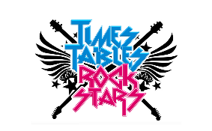

Have a lovely, relaxing break,
Year 3 Teachers

