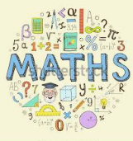
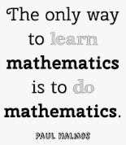
Maths at Wibsey Primary School
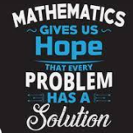
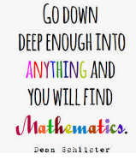
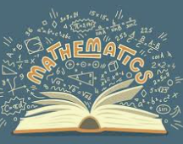

“Without mathematics there is nothing you can do. Everything around you is mathematics. Everything around you is numbers.”
Shakuntala Devi

What our children learn in Maths (Intent)
Wibsey’s key ethos statement ‘A community of learners’ is a fundamental value of maths teaching. The pupils are supported to develop their independent and collaborative skills, being supportive of others’ and helping each other to understanding mathematical concepts. The teachers encourage a growth mindset approach and key teaching points are delivered ensuring all pupils are challenged and achieve success.

The intent of our mathematics curriculum is to design a curriculum which is accessible to all and will maximise the development of every child’s ability and academic achievement, through personalised learning for each pupil, a challenging and engaging curriculum and a positive attitude towards Maths.

At Wibsey Primary School we deliver lessons that are creative and engaging. We want children to make connections across mathematical ideas to develop their fluency, reasoning and problem-solving skills. Maths is taught as an engaging and hands on subject where pupils are actively encouraged to explain their workings verbally, in written form and through concrete manipulatives to realise and explore that there is more than one way to solve a problem. Children are encouraged to work collaboratively to develop their explanation, demonstration and problem-solving skills.

We intend for our pupils to be able to apply their mathematical knowledge other subjects within the curriculum. It is important that our children understand how Maths is essential to everyday life, and how they will use and apply this in their future career.

As our pupils continue through the school, we want them to be able to understand the role of Mathematics in the world, have the ability to reason mathematically and have a sense of enjoyment and curiosity about the subject.

Implementation – How we plan and teach Maths
Mathematics at Wibsey Primary School teaches children how to make sense of the world around them through developing their ability to calculate, reason and problem solve. It is a core subject with a range of cross-curricular links and we expect teachers to capitalize on opportunities from other subjects to rehearse and apply skills in a variety of contexts. Our mathematics curriculum is carefully and thoroughly planned and sequenced into a ‘Learning Continuum’. This is an ‘all inclusive’ approach and has the following benefits:

• Personalised learning for each pupil
• Challenge/small groupings
• Daily interventions at the point of need (IPN) to address misconceptions

We implement the Learning Continuum by creating a pre-skills assessment which takes place prior to each strand of the Maths National Curriculum. This assesses the whole range of knowledge (on that strand) from years 1 to the specific year group. From this, children are grouped, depending on where their current knowledge lies on the continuum, and then receive a differentiated input. This models a similar task to the one which children will be given to complete after their input. During this time, teachers will carry out thought modelling and model the use of relevant manipulatives to support engagement with the given task. This allows teachers to fill the gaps of knowledge and misconceptions, whilst teaching the current year group curriculum.

Lessons are planned to include ‘Fluency’ and ‘Reasoning and Problem Solving’ questions and tasks. This is to ensure pupils’ develop are able to apply their knowledge in different ways. All pupils are encouraged to explain their reasoning and their approaches to mathematical problems; they are encouraged to listen to others’ methods to realise that there is more than one way to approach maths and to explore the most efficient methods to take forward in their own learning.

The Learning Continuum resources are created by teachers and aim to provide a balance between fluency, reasoning and problem solving for all children by incorporating relevant mathematical models, images and key vocabulary.

Impact – What difference does the Maths curriculum make to our children?
The children at Wibsey Primary School value and enjoy maths. Children are able to notice the importance of Maths in the wider world around them, how it is used and why it is important. They are eager to make progress and learn new mathematical concepts as well as practise and embed the maths that they have already learnt previously.

Regular and ongoing assessments are used to inform teaching to support and enable the success of each child. These factors ensure that we are able to improve standards for the end of year results in KS1 and KS2 and allow our children to all reach their full potential.

Maths teaching ensures that pupils are secondary ready and also ready for the world of work.

