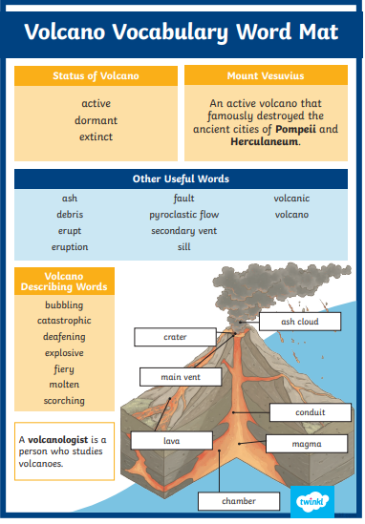

**Reading Challenge**: Read your reading book and complete a reading task.



**Spelling/Geography Challenge:** Choose 10 words from the Volcano Vocabulary Word Mat. Learn what they mean and how to spell them.

**Maths challenge**: TTRS and mathletics task



Have a lovely, relaxing break,

Year 3 Teachers