

**WIBSEY PRIMARY SCHOOL**

|  |
| --- |
| **Policy for Educational Visits, Outdoor**  **Learning and Adventurous Activities** |

|  |  |  |
| --- | --- | --- |
| Agreed by Governors  Date: | Full Governors | x |
| Finance and General Purposes |  |
| Teaching and Learning |  |
| Signed on behalf of Governing Body by Chair of Committee: | Lisa Knowles |  |
| Approved | 23.03.23 |  |
| Review | 23.03.26 |  |

## 

## **Rationale**

Wibsey Primary School acknowledges the immense value of educational visits and the role that they play in the delivery of a broad and balanced curriculum and in providing pupils with valuable experiences which enhance their learning in school. Through direct experience, they also provide an opportunity to extend the learning of all children by enriching their understanding of themselves, others and the world around them. Good quality learning beyond the classroom adds much value to classroom learning: we believe that every young person should experience the world beyond the classroom as an essential part of learning and personal development, whatever their age, ability or circumstances.

**Scope and responsibilities**

This policy applies to all educational visits, outdoor learning and adventurous activities that pupils at Wibsey Primary School undertake. It should be read alongside Bradford LA’s ‘Policy for Educational Visits, Outdoor Learning and Adventurous Activities’. It also reflects advice and guidance from OEAP.

The Headteacher has delegated responsibility to two Educational Visits Co-ordinators. They have the training and experience to enable them to competently discharge their responsibilities.

The Educational Visits Co-ordinators are: Karen Yates (DHT) and Caroline Ellis-Barker (AHT).

**Aims**

The aims of this policy are to:

* To provide a variety of first-hand learning experiences which will enhance curriculum provision by acting as a stimulus and thereby maximise every child’s potential;
* To provide experiences that will aid the acquisition of new skills and attitudes and extend children’s personal horizons through greater appreciation and understanding of the world and its people;
* To enhance personal and social development by helping all children develop self-esteem, co-operation and respect;
* To promote a positive and knowledgeable response towards personal health and well-being;
* To foster a concerned awareness and sensitivity about the environment;
* To encourage the involvement of parents in the learning process by including them and valuing their skills, knowledge and experience which they bring.

**Objectives**

* To formulate a whole school programme showing progression, variety and suitability linked to the National Curriculum and in accordance with the long-term planning;
* To ensure every child has the opportunity to benefit from educational visits;
* To ensure all visits are safe, purposeful and appropriate to meet the educational needs of the children taking part;
* To enable the school to identify appropriate functions, responsibilities, training, support and monitoring for governors, staff, volunteers, children and providers involved in educational visits;
* To ensure that whenever appropriate, further advice is sought from the LEA and from other technically competent sources.

# **Definitions**

The definitions used within this policy are:

* ‘In loco parentis’ means that the group leader of any school trip or educational visit has a duty of care over the pupils in place of a parent/carer.
* ‘School trip’ means any educational visit, away-day or residential holiday organised by Wibsey Primary School which take pupils off-site.
* Local Visit means any visit within the defined local area.
* ‘Residential’ means any school trip which includes an overnight stay.

# 

# **Types of Visits**

At Wibsey Primary School pupils have a wide range of visits, which are progressive from the local area and nearby providers of outdoor educational experiences in Foundation Stage to slightly further afield in Key Stage 1. Key Stage 2 pupils travel further afield and have opportunity to attend a residential visit.

At Wibsey Primary School visits are defined as Level 1 (routine), Level 2 (non-routine) and Level 3 (specific consent) – see Appendix 1.

|  |  |  |
| --- | --- | --- |
| **Level 1: Routine** | **Level 2: Non-Routine** | **Level 3: Specific Consent** |
| Local Area visits / offsite activities / regular curriculum:   * These visits **do not** involve transport and / or do not start before or go beyond the school day * These can be ‘ad-hoc’ where they are dependent on the right conditions on the day | These visits:   * Involve transport;   or   * Extend beyond the school day;   or   * Are new visits. | These visits:   * Are residential;   or   * Involve adventurous activities;   or   * Contain activities at a water margin. |

# **Key roles and responsibilities**

**Governing Body**

The Governing Body:

* Has overall responsibility for the implementation of the Policy for Educational Visits, Outdoor Learning and Adventurous Activities at Wibsey Primary School and needs to ensure that the LA guidelines have been adhered to.
* Has overall responsibility for ensuring that the Policy for Educational Visits, Outdoor Learning and Adventurous Activities, does not discriminate on any grounds, including, but not limited to the legally identified protected characteristics.
* To ensure all aspects of risk management have been considered and carried out prior to departure.
* Has responsibility for handling complaints regarding this policy as outlined in the school’s Complaints Policy.
* Agrees all residential visits and those involving outdoor and adventurous activities, including those at water margins.
* Reviews the EV policy and procedures including incident and emergency management systems.

**Headteacher**

The Headteacher:

* Delegates responsibility for the organisation of Educational Visits to the Educational Visits Coordinator/s and ensures the necessary training is received;
* Ensures that visits comply with regulations and guidelines provided by the L.A, Governing Body and the school’s own Health and Safety Policy;
* Ensures that adequate child protection procedures are in place;
* Ensures that all the necessary actions have taken place prior to the visit including completion of the risk assessment.
* Ensures that there is adequate and relevant insurance cover.

**Educational Visits Coordinator (EVC)**

The EVC has overall responsibility for educational visits and school trips. It is the responsibility of the

Educational Visits Coordinator to:

* Update, communicate and discuss school policy in relation to educational visits;
* Provide support for staff planning and organising visits and ensure that all necessary actions have been taken before the visit;
* Ensure all risk assessments have been completed;
* Ensure the group leader has the relevant skills, qualifications and experience and that all supervisors are competent and suitable and have appropriate clearance;
* Ensure appropriate arrangements have been made for the medical needs and special educational needs of the children;
* Ensure transport arrangements are appropriate;
* Ensure that ratios of staff to pupils are appropriate;
* Ensure school has the names and addresses of all adults and children in the travelling group, and the contact details of parents and the staff’s and volunteer’s next of kin;
* Ensure that school is aware of departure and return times;
* Liaise with, and take advice from, the LA Educational Visits advisor as needed;
* Monitor the work carried out during and as a result of the visits;
* Oversee the balance of visits within a year group, across an academic year and on a pupil’s journey across school.

**Group Leader**

The Group Leader in charge of the trip is ‘in loco parentis’ and has a duty of care to all pupils on the trip. He / she is in overall charge of the planning as well as the supervision and safety of the party throughout the visit. This may include delegation of duties to other members of staff and volunteers. Delegation of duties must fall within each person’s competency however the key responsibility remains with the Group Leader. It is the responsibility of the group leader to:

* Agree all plans with the EVC;
* Appoint a deputy in conjunction with EVC;
* Undertake and complete the planning and preparation of the visit including the briefing

of group members and parents;

* Ensure that the necessary documentation is available for the Educational Visits Coordinator at all times;
* Where needed undertake an exploratory visit;
* Complete a comprehensive risk assessment with the EVC;
* Ensure all adults are aware of any special needs or medical issues;
* Ensure that children understand their responsibilities and key safety information;
* Carry out a review of the visit.

**Staff**

Staff will be responsible for following the Educational Visits Policy, and for ensuring pupils do so too. They will also be responsible for ensuring the policy is implemented fairly and consistently. It is the responsibility of other staff and adults to :

* Do their best to ensure the health and safety of everyone in the group;
* Care for each individual child as any reasonable parent would;
* Follow the instructions of the Group Leader and help with control and discipline. Non-teachers should generally not have sole charge of children except where risks to health and safety are minimal;
* Stop the visit or activity if they think the risk to the health or safety of the children in their charge is unacceptable.

**Parents and other volunteers**

When accompanying pupils on visits parents and carers have a duty of care. They should be clear about their roles and responsibilities. They must:

* Demonstrate a duty of care for all pupils;
* Not be left in sole charge of pupils;
* Follow the instructions of the group leader throughout;
* Speak to a member of staff regarding any concerns.

At no time should any adult who does not have a DBS be left alone with any child / children.

Parents should be able to make an informed decision on whether their child should go on a visit. They should be given sufficient information in writing and invited to any briefing session as needed. Parents will need to:

* Ensure the school has up to date emergency contact details;
* Sign the consent form;
* Give the group leader any relevant information about their child’s physical, emotional or psychological health which may be relevant to the visit;
* Provide details of who will collect their child (where the visit returns after school hours) and ensure that their child is collected on time.

**Pupils**

Pupils are responsible for following instructions from teachers while on educational visits. It is the responsibility of the Group leader to make sure that pupils know that they must:

* Not take any unnecessary risks;
* Follow the instructions of the leader and other adults;
* Look out for anything that might hurt or threaten anyone in the group and tell the group

leader about it;

* Dress and behave sensibly and responsibly;
* Know what to do if they become separated from the group or approached by a stranger;
* Not undertake any task that they fear or that they think will be dangerous.

Pupils are responsible for behaving in a manner which matches the ethos of Wibsey Primary School, and for following the behaviour rules set out in the school’s Behaviour Policy as they relate to the Policy for Educational Visits, Outdoor Learning and Adventurous Activities. Any child whose behaviour may be considered to be a danger to themselves or to the group may be stopped from going on the visit. The curricular aims of the visit for these pupils should be fulfilled in other ways.

Any pupil whose behaviour choices may be considered to be a danger to themselves or to the group may be stopped from going on the visit.

If the Group Leader feels such action may be necessary, they should speak to the EVC and Headteacher.

# **Training of staff**

* Teachers and Associate Staff will receive training on the Policy for Educational Visits, Outdoor Learning and Adventurous Activities as part of their new starter induction.
  + Teachers and Associate Staff will receive regular and ongoing training as part of their CPD.
  + All teachers new to the school will receive training after induction but before their first educational visit.

**Parental Consent**

* **Level 1 visits: Routine acknowledgement**

Whilst it is not a legal requirement to gain parental consent for school activities for children over nursery age, informed parental consent is required for all visits. A local visits consent form is signed on enrolment to the school for routine local visits and activities which are a part of our normal educational provision during the school day. These activities do not involve transport. Information regarding the nature of the types of visit will be included school handbook. We will always aim to fully inform parents by letter or message sent via the school APP of the nature of each visit or activity, remind parents that they have acknowledged this, and give opportunity to update information and emergency contact details as needed. On occasions a curriculum opportunity may become available at short notice and we will always aim to notify parents that their child will be offsite but this may not be possible.

* **Level 2 visits: Non-routine consent**

Written consent, which may be via a letter or message on the school APP, will be gained for those visits which are:

* Non-routine visits / activities; and those which fall outside of normal hours;
* Educational visits outside the local area;
* Visits that fall outside of normal school hours;
* Any visit that involves the use of transport.

We will fully inform parents, by letter or message on the school APP, of the nature of each visit or

activity.

* **Level 3: Specific consent**

Written consent, which may be via a letter or message on the school APP, will be gained for every individual visit or activity which involve a higher level of risk including, but not limited to, longer journeys, residential visits and adventurous activities. We will fully inform parents by letter or through a parental meeting of the nature of each visit, activity or series of a similar nature.

Parents will be informed of any educational visit and activity by letter sent out via the APP and will have the opportunity to withdraw their child from taking part. The Group Leader should ensure that parents are given information about the purpose and details of the visit and are invited to a briefing session for longer visits, residentials and those that involve adventurous activities. Special arrangements may be necessary for parents for whom English is a second language.

It is the responsibility of parents to:

* Sign and return the consent form;
* Ensure the school has up to date contact details;
* Ensure their child’s class teacher has any information about their child’s health which

might be relevant to the visit and that any prescribed medication (including inhalers and

epi-pens) is in school on the day of the visit.

**Medical information**

We will use the medical information on record in our Student Information Management system alongside any updated information which parents have provided for visits and activities. Where visits or activities involve a higher level of risk it may be appropriate for separate medical information and consent forms to be completed.

The school has adopted the Bradford ‘Administration of Medication’ policy. In line with the policy, when children are undertaking a residential visit parents must request the administration of prescribed medication via the completion of the parental agreement. Care must be taken by parents in identifying doses and times of administration as staff will follow the parental instruction. Should staff have a query about medication they must contact the parent for clarification. It must never be left for staff to diagnose or decide where and when the medication is required or administered. Two first aiders will administer the medication with both signing alongside the given dosage and time.

On day visits, the first aider will collect the medication and the information held by the school as completed by the parent which details administration and dosage.

School will check the name and date of birth on the label of the medication with the parent agreement used for dosage and time of administration.

# **Planning an Educational Visit**

**EVOLVE: Visit Planning and Management System**

A web-based system (Evolve) is used to facilitate the efficient planning, management, approval and evaluation of visits. All staff can access their own account which is set up by the Educational Visits Co-ordinator.

An EVOLVE notification must be completed for all visits. All educational visits are planned using the agreed flowchart for visits (see Appendix 2).

The visit lead is responsible for completing the EVOLVE notification. This must include the Approval Form, letter to parents, itinerary and plan B, risk assessment and planner.

Approval of visits will be made as detailed below.

|  |  |
| --- | --- |
| **Type of Visit** | **Approval and Consent** |
| **Level 1** | **Local visits parental consent for frequent activities** covers the time a pupil is on roll. Parents to be notified before each visit. |
| **Level 2** | **Approval for each visit by EVC.**  **Approval by HT for new visits**  **Parental consent** obtained for each visit. |
| **Level 3** | **Approval by Local Authority.**  Endorsements from Governors.  **Specific parental consent** for visit and activities. |

**Governing Body**

The governing body has a strategic role to set the vision and direction of the school and has responsibility for its educational and financial performance. To enable this, it will hold the Headteacher to account by oversight of learning beyond the classroom opportunities to ensure that the educational experiences are of high quality, that best value is obtained and financial regulations are adhered to.

**Adviser**

Advice will be sought for visits abroad, residential, provider-led adventurous and all self-led adventurous activities regardless of location. All risk assessments for residential visits are required to be submitted to the LEA advisor for approval at least 28 days in advance.

**Headteacher**

Approval for all visits abroad, all adventurous activities, residential visits and non-local day visits.

**Educational Visits Co-ordinator**

Approval for all Level 1 visits Level 2 visits that have been undertaken in previous years.

**Residential Visits**

School offers at least one residential visit to pupils during their time at Wibsey Primary School. All venues used carry an LOTC Quality Badge. On all residential visits:

* Approval is given by the Chair of Governors and by the Local Authority;
* Staff ratio should be at least 1:8;
* The school APP will be used to inform parents of safe arrival / pending departure;
* There must be separate male / female sleeping and bathroom facilities for pupils / staff;
* The whole group should be aware of the accommodation layout, fire exits and muster points, and regulations;
* Any locks on doors should work but staff should have appropriate access as needed;
* There should be provision for SEND pupils and any who fall sick;
* The fire alarm must be audible throughout the building and a fire drill should take place as soon after arrival as possible;
* There should be an appropriate number of supervisors on duty during the night.

**Planning an Educational Visit: The Process**

# **Approval Form and Visit Planner**

The school most approve all visits and off-site activities. The Approval Form (see Appendix 3) should be completed by the year group as soon as possible and outline the purpose for the visit. Once the initial approval has been given detailed plans will be drawn up. The nominated Group Leader should use the Visit Planner (see Appendix 4) to ensure all appropriate arrangements have been made.

Where a provider is chosen that does not carry an LOTC Quality Badge then a Provider Statement (see Appendix 5) must be obtained.

1. When the designated group leader has not visited the provider in the last 12 months the group leader should undertake a pre-visit in order to:

* Ensure that the venue is suitable to meet the aims and objectives of the visit;
* Assess potential areas and levels of risk;
* Ensure that the venue can cater for the needs of the staff and children in the group;
* Ensure that the group leader is familiar with the area before taking a party of children.

Pre-visits should be undertaken for all new visits and Level 3 visits.

# **Finance and Charging Arrangements**

Charges for educational off-site visits and adventurous activities, including charges for admission and transport, are made as requests for voluntary contributions. Remission of charges are made in line with legislation for maintained schools and DfE guidance.

* The financial procedures outlined in the school’s Charging Policy (2021) will always be followed when arranging educational visits.
* The school will act in accordance with the DfE’s guidance document ‘Charging for school activities’ and, therefore, will only charge for trips which are classed as an ‘optional extra’. This is education provided outside of school time which is not:
* Part of the national curriculum;
* Part of a syllabus for an examination that the pupil is being prepared for at the school;
* Part of religious education.
* Any charge made per pupil will not exceed the actual cost of providing the trip, divided equally by the number of pupils participating. All contributions are voluntary, but if school does not receive enough voluntary contributions, the visit may be cancelled. Once visit arrangements are booked and confirmed, if contributions to a trip exceed the total cost of the trip, a refund will be given. Any excess of expenditure will be subsidised by the school fund. Residential payments can be staggered but should be paid in advance. On residential visits there may be a non-refundable deposit and details of this will be given with any payment advice.
* If a parent wishes their child to take part in a school visit, but is unwilling or unable to make a voluntary contribution, the child will participate fully in the visit as long as parental consent is given and funds are available.
* Governors will make every effort to financially support a child’s participation in a visit, where parents are undergoing financial difficulty. Parents can discuss any difficulties in confidence with the Headteacher or Deputy Headteacher.
* All letters to parents regarding school trips will include a clause explaining what will happen in the event that the trip is cancelled or a pupil cancels their place on the trip.
* In the event that the trip is cancelled due to unforeseeable circumstances, a refund will be given to parents. The headteacher will consult the governing body on the matter, taking into account the cost to the school, including alternative provision costs.
* In the event that a pupil cancels their place on a trip, it is at the headteacher’s discretion as to whether a refund is given to parents. Wibsey Primary School takes a common-sense approach to refunds and cancellations, ensuring that all pupils are treated equally.

# **Communicating with Parents**

Parents need to be aware that the teachers on the visit will be acting in their place – ‘in loco parentis’ – and will exercise the same care that a prudent parent would. The following information on matters that might affect pupils’ health and safety is useful to parents, and will in included in letter to parents prior to a visit:

* dates of the visit;
* times of departure and return;
* mode(s) of travel including the name of any travel company;
* visit’s objectives;
* details of the activities planned;
* clothing and equipment to be taken.

# **Staffing and Supervision**

* 1. **Supervision**

It is important to have a sufficient ratio of adult supervisors to pupils for any off-site visit and there should always be enough supervisors to cope effectively with an emergency. Supervision ratios should reflect the specific needs of the group, the venue and the activities to be undertaken. The factors taken into consideration include:

* sex, age and ability of group;
* special needs pupils including medical needs;
* nature of activities;
* experience of adults in off-site supervision;
* duration and nature of the journey;
* type of any accommodation;
* competence of staff, both general and on specific activities.
* Competence and behaviour of pupils;
* First Aid cover.

**The ratio plus one rule is operated to ensure that if any adult is indisposed during the visit for**

**any reason ratios are still within guidelines**

As general guidelines, the following ratio of adults to children should be used:

Nursery and Early Years, visits off-site may be as low as: 1:2

Reception 1:5

Key Stage One, visits off-site on foot: 1:8

Key Stage One, visit via school mini bus 1:8

Key Stage One, visits off site involving public transport: 1:6

Key Stage Two, visits off-site on foot: 1:10

Key Stage 2, visits via school mini bus 1:10

Key Stage Two, visits off-site involving public transport: 1:8

Residential - As required but 1:8 as a minimum

Pupils who have a one-to-one support in class as identified in their EHCP fall outside of these ratios.

Regardless of the suggested ratios, each visit will be assessed individually through the school’s risk assessment procedure for educational visits and any required revisions to supervision ratios adjusted. It may be necessary to adjust the ratio depending on the maturity / behaviour of the class / individuals.

Where a high adult:pupil ratio is required, it is not always feasible to use school staff alone.

Parents with may be used to supplement the supervision ratio. They should be carefully selected and ideally be well known to the school and the pupil group. Ideally, they will not be accompanying with their own child and should have appropriate DBS clearance.

All adult supervisors, including school staff and parent helpers must understand their roles and responsibilities. In particular, they must be aware of any child who requires closer supervision, such as those with special needs or behavioural difficulties. Teachers retain responsibility for the group at all times, and pupils who require close supervision should be assigned to a teacher or their regular in school support.

For the protection of both adults and pupils, all adult supervisors should ensure that they are not alone in a one to one situation with a child.

During the visit, regular head counting of pupils should take place. The group leader should establish rendezvous points and tell children and other adults what to do if they become separated from the party. Where possible pupils should wear a wrist band detailing the school contact details.

* 1. **Staff Briefing**

A briefing session for all staff should be held before the visit. Staff briefings should include:

* Staff roles and responsibilities;
* Full details of the visit;
* Special Needs and Medical Issues;
* Child Protection arrangements;
* Rules and expectations of behaviour;
* First Aid, Accident Reporting and Emergency Plans;
* Risk Assessment.
  1. **Volunteer Briefing**

A briefing session for all volunteers should be held before the visit. This will be different to the staff briefings as they do not receive SEND and medical information. Their briefing should include:

* Staff roles and responsibilities;
* Full details of the visit;
* Child Protection arrangements;
* Rules and expectations of behaviour;
* First Aid, Accident Reporting and Emergency Plans;
* Risk Assessment.

# **Transport and Travel**

Careful thought must be given to planning transport to support off-site activities and visits. Staff must

follow any specialist guidance provided by your employer regarding driving minibuses.

* Where possible the school mini buses will be used. If this is not possible the school office will arrange transport with an appropriate coach company.
* The Business Lead is responsible for arranging the annual maintenance of the minibuses, including MOTs and road tax. Any potential risks, defects or damage identified must be reported upon return to the school from any visit.
* All children must wear seat belts throughout the journey and staff must ensure these are secure at the start of each journey and during the journey at reasonable intervals. Children will be made aware of the basic safety rules for travel. Children should not sit in the front row of the coach or in the middle, back row seat. Adults should be seated throughout the coach.
* The use of cars or private taxis for shorter activities or small numbers of pupils can be considered. Authorised taxi companies must be used and if cars are used the driver’s insurance must cover such activities.
* The Business Lead maintains the up to date list of staff members who hold the required licence and have completed specific training which allows them to drive the school minibus’

The Group Leader should consider:

* Journey time and distance, including the need for any stopping points on longer journeys;
* Traffic conditions on the day;
* Weather;
* Passenger safety;
* Supervision.

If public transport is to be used all staff and pupils must be briefed on procedures on platforms and on busy streets.

**6.1 Use of cars**

On occasions a car may be used to transport additional adults and / or in an emergency. The use of

cars is discouraged for transporting pupils; but if used the following should be adhered to:

* The car should be roadworthy;
* The driver has the appropriate licence and business insurance;
* Drivers ensure pupils wear seat belts and use booster seats if necessary;
* Drivers will not be unaccompanied with a child in their care.

On occasion a taxi may be required. An authorised taxi company will be used and preferably adults

will be transported via taxi. Where a child needs to be in a taxi they will be with a member of staff and unless it is an emergency parents will have been informed.

# **Insurance and licensing**

* When planning activities of an adventurous nature in the UK, the educational visits coordinator will check that the provider of the activity holds a current licence.
* The council arranges insurance for off-site activities and a copy of this is available by contact with the Business Lead.

# **Health and Safety**

# **Risk assessment process**

* School has a series of generic risk assessments, which are likely to apply to the activity wherever it takes place eg sports activities, transport, local walks.
* Visit specific risk assessments, which differ from place to place and group to group are completed by the Group Lead, Deputy and class teacher prior to each visit.
* A comprehensive risk assessment should always be carried out and completed by the group leader with the EVC. The group leader and other supervisors should continually reassess the risks throughout the visit and take appropriate action if pupils are in danger. For level 1 and Level 2 visits this should be completed at least two weeks before the date of the visit to allow time for signing off by the EVC. It can be amended at any point up to, and during, the visit. For Level 3 visits this is completed prior to 28 days before the visit.
  + The following factors should be considered when assessing the risks:
* The type of activity and the level at which it is being undertaken;
* The location;
* The competence, experience and qualifications of supervisory staff;
* The group members’ ages, competence, fitness and temperament;
* Children with special educational or medical needs;
* Seasonal conditions, weather and timing;
* The day and time of year – seasonal weather conditions;
* The travel arrangements;
* Emergency procedures.
* The process is as follows:
* Identify the hazards;
* Decide who might be harmed and how;
* Evaluate the risks and decide on precautions;
* Record your findings and implement them;
* Review your assessment and update if necessary.
* All accompanying staff will receive a copy of the risk assessment and a copy of the

risk assessment will be left at the office on departure. An additional copy is kept on

Evolve.

* A sample risk assessment form is available in Appendix 6.
  1. **First Aid**

**For children in EYFS there is a statutory requirement that there is at least one person who holds a current paediatric first aid certificate on the visit.**

* In Key Stage 1 and Key Stage 2 a qualified first aider should be present on each visit and appointed to be in charge of first aid.
* A first aid kit will be taken on all visit is and the school office will ensure these are complete.
* All staff involved should be aware of any medical issues regarding the children. This information is given in a medical form. Medicines relating to particular children and information regarding administration should be given to the designated member of staff.
* Any accident must be reported on CPOMS and any other health issues related to the parents.
* Where possible, a first aider should accompany any child to hospital if needed and be the main point of contact for parents.
  1. **Safeguarding and Child Protection**

Safeguarding procedures should be considered as part of the planning process with additional consideration for residential visits. Visit Leads should:

* Liaise with the Designated Safeguarding Lead (DSL) and other staff to identify any relevant safeguarding issues
* Have access during a visit to the DSL (or trained deputy) either directly or through the school or direct contact if out of school hours.

Any volunteers who accompany any visit or activity will be chosen for competency and vetted under the DBS procedures. They will be directly supervised by a member of staff. If they are to have significant unsupervised access to children then an enhanced DBS disclosure will be obtained and they will undergo induction and training in their role and responsibilities as detailed in employer and school policies and local procedures. Reference should also be made to the schools Safeguarding and Child Protection Policy (2022) and the Safeguarding Statement (2022).

**All adults who are given unsupervised or regular access to children must have obtained an appropriate DBS check.**

* 1. **Head Counts**

Whatever the length of the visit, regular headcounts should be taken, particularly before leaving any venue.

All adults should carry a list of pupils

Risk assessments should identify the pupils on each mini bus / coach.

EYFS and Key Stage 1 pupils should be easily identifiable eg the use of a hi-viz jacket.

The risk assessment should identify rendezvous points and tell pupils what to do if they get lost.

If a child is lost then the Group Leader will invoke the Lost Child Policy.

**8. Accident and Emergency**

In the case of an incident during a visit all members of staff will follow the establishment’s incident management plan as detailed in Appendix 7.

* A school mobile phone will be taken on all visits. Any delay in return times should be communicated to school and parents will be notified via an APP message. Staff taking their own mobiles for contact will ensure that the contact numbers are on the risk assessment and within school.
* The group leader will take contact details for all pupils and a list of pupils, staff and adults attending will be left at the office on departure. These will be on an encrypted I-Pad where possible. These will be deleted after the visit and any paper copies will be shredded.
* In the event of an incident resulting in harm to a child or adult then school must be contacted as soon as possible and the Headteacher or Deputy Headteacher informed. If the incident is of a less serious nature the parents or next of kin will be informed about what has happened and the action that has been taken so far.
* If the incident is very serious the Headteacher or Deputy Headteacher will contact the LEA. As soon as possible the Group Leader should write down all relevant facts, witness details etc as appropriate. The action taken should be logged and an accident report form completed on return to school.
* The group leader and accompanying staff should be aware of the procedures regarding emergencies. An emergency’s procedures card is to be made available for each member of staff.
* Media enquiries must be referred to the Headteacher or, if they are not available, the Deputy Headteacher.
* All staff on the visit will carry an Emergency Procedures Card.

1. **Monitoring of visits and procedures**

Governors will monitor the implementation of this policy by acting as a critical friend in monitoring the implementation and effectiveness of the policy.

The Educational Visits Co-ordinator will ensure that there is a system in place for appropriate monitoring of visits and activities. This will include some attendance on visits and at staff and parent briefings.

1. **Inclusion and SEND**

At Wibsey Primary School we endorse the principles for children of a presumption of entitlement to participate, accessibility through direct or realistic adaption or modification and integration through participation with peers.

We acknowledge that it is unlawful to treat a young person with a protected characteristic less favourably or fail to take reasonable steps to ensure that young people with protected characteristics and disabilities are not placed at a substantial disadvantage without justification.

We also acknowledge that expectations of staff must be reasonable, so that what is required of them (to include a young person) is within their competence and is reasonable. Reference should also be made to the school Inclusion Policy and SEND Policy (2021).

* Pupils should have a clear understanding about what is expected of them and what the visit will entail. They should be told about any potential dangers and how they should act to ensure their own and other’s safety.
* Children should be assessed to ensure they are capable of undertaking the proposed activities. During the visit they should not be coerced into activities they fear. Any child whose behaviour is such that the group leader is concerned for their, or others’ safety, should be withdrawn from the activity and the group leader should consider whether such pupils will return home early.
* Every effort will be made to ensure that school journeys, visits and activities are available and accessible to all who wish to participate, irrespective of special or medical needs, ethnic origin, gender, religion etc.
* Children with special educational or medical needs will not be excluded from school visits. Where possible, activities and visits will be adapted to enable pupils with SEND to take part and every effort be made to accommodate them whilst maintaining the safety of everyone on the visit. Where this is not possible an alternative activity of equal educational value will be arranged for all pupils. Special attention should be given to appropriate supervision ratios and additional safety measures may need to be addressed at the planning stage.

School will consult the SENDCo and parents (as required) prior to planning the visit and with their support will:

* Consider the suitability of the venue and its adaptations for access;
* Look for inclusive activities;
* Use additional staff and ensure that relevant staff are trained;
* Liaise with the venue regarding any pupil’s specific needs;
* Create a personalised risk assessment if needed.

1. **Behaviour**

The school behaviour policy should be reiterated to pupils and parents before a visit, to reduce the opportunity for misunderstanding both expectations and the sanctions that may be invoked where the policy is breached.

**12. Evaluation**

* An evaluation of each visit will be made. After consultation any issues should be addressed, resolved and noted. Children should also be involved in this process.
* Any ‘near misses’ should be reported to the EVC.
* Any appropriate letter of thanks should be written and sent. Accounts should be checked, finalised and closed.

1. **Data Protection**  
   It is vital for the health and safety of those involved in visits that relevant information is available to leaders and external providers for planning activities, and in the event of an emergency. The school GDPR Policy allows appropriate sharing of personal data for visits, and sets out procedures for handling it.

# **Policy review**

This policy is reviewed every two years by the Governing Body.

**Other Policies**

Other policies to which the Religious Education Policy links are:

* Administration of Medicine Guidance
* Behaviour Policy (2022)
* Charging Policy (2021)
* Complaints Policy (2018)
* Data Protection (2016)
* DBS Policy Statement (2021)
* Equality Policy (2019)
* Freedom of Information Policies and Procedures (2016)
* Health and Safety Policy (2021)
* Inclusion Policy
* Lost Child Policy
* Use of Mobile Phones Policy (2021)
* Safeguarding Statement (2022)
* Safeguarding and Child Protection Policy (2022)
* SEND Policy (2021)
* Staff Code of Conduct
* Staff Development / CPD Policy

### ECE92BE1Appendix 1

**Wibsey Primary School**

**Level of Visit – Definitions**

|  |  |  |  |
| --- | --- | --- | --- |
| **Level of Visit** | **Level 1: Routine** | **Level 2: Non-Routine** | **Level 3: Specific Consent** |
| **Definition** | Local Area visits.   * These visits **do not** involve transport and / or do not start before or go beyond the school day * These can be ‘ad-hoc’ where they are dependent on the right conditions on the day   See below for definition of local area | These visits:   * Are outside the defined local area;   or   * Involve transport;   or   * Extend beyond the school day;   or   * Are new visits | These visits:   * Are residential;   or   * Involve adventurous activities;   or   * Contain activities at a water margin. |
| **Parental consent** | Via local area permission on entry  Parents informed of visit via an APP message | Via local area permission on entry  Parents informed of visit via an APP message | Via local area permission on entry  Parents informed of visit via an APP message |
| **Proposal** | KMY | Established: KMY  New visits: NMC | NMC  Endorsed by Governors |
| **Risk Assessment Deadline** | 2 weeks prior to visit   * Initial check by CEB * Sign off KMY | 2 weeks prior to visit   * Initial check by CEB or KMY * Sign off KMY for established visits; NMC for new visits | Needs LA approval  4 weeks prior to visit   * Initial check by KMY as EVC – submit to Head * NMC submit to LEA * LEA sign off |
| **Where** | Recorded on Evolve ‘Local Area Visit’ Module | Recorded on Evolve | Recorded on Evolve ‘ |

**Definitions**

**Ad-hoc**: Local activities for example a walk to Wibsey library that are a planned part of the curriculum but are dependent on the right conditions on the day.

**Adventurous**: This is not an exhaustive list but includes all activities in open country; swimming (except publicly life guarded pools), anything on or in the water; hill walking; abseiling; underground exploration; archery; horse riding and any other activities involving skills inherent in any of the above.

**Local Area**: The area around the school bounded by Wibsey Roundabout, the cenotaph, Arce Lane and the far side of the High Street.

**Routine**: DfE “….no more than an everyday level of risk….covered by school’s current policies and procedures……They can be considered as lessons in a different classroom

**Water Margins**: Activities that take place near to, or in the water – such as a walk along a river bank, or seashore, collecting samples from ponds or paddling in gentle (hardly moving), shallow (up to the knees) water.

**Appendix 1: Definition of the local area**

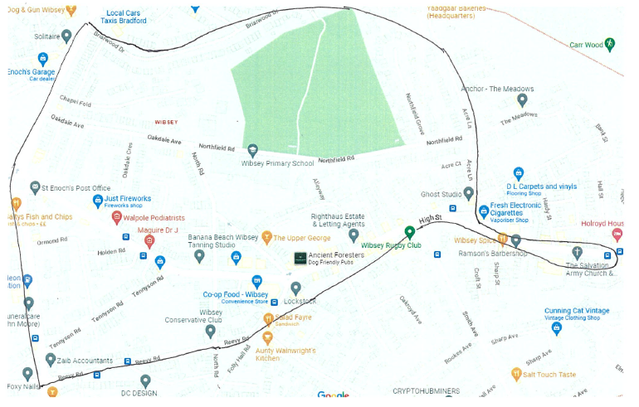

The local area includes:

* Chapel Fold
* Acre Lane
* The Salvation Army Church
* The Library
* The High Street

**Appendix 2 Flowchart for Educational Visits**

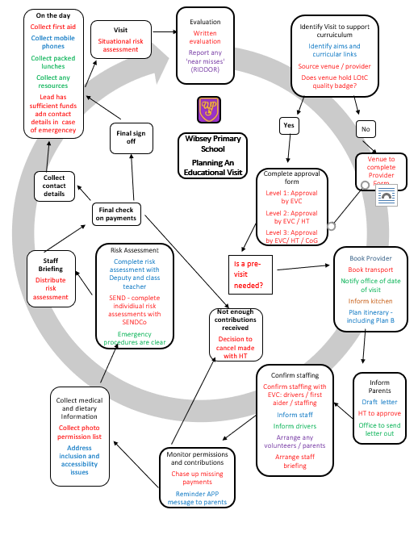

**Appendix 3**

**Wibsey Primary school**

**SCHOOL VISITS AND OFF-SITE APPROVAL FORM**

This form MUST be completed at least four weeks prior to the proposed visit and before

any arrangements have been confirmed.

|  |  |  |  |  |  |
| --- | --- | --- | --- | --- | --- |
| Year Group  Class |  | | Place of visit (include address) | |  |
| LOTC Quality Badge | | Yes / No |
| Proposed date/s |  | | Distance from school | |  |
| Number of children |  | | Number of adults required | |  |
| Group Leader |  | | Proposed Deputy | |  |
| Cost per child |  | | Running cost per child for academic year | |  |
| Breakdown of cost | | | | | |
|  | | | | | |
| Transport and Travel Arrangements (including coach and taxi details and costings) | | | | | |
|  | | | | | |
| Curriculum Link / Activities | | | | | |
|  | | | | | |
| Additional Information | | | | | |
|  | | | | | |
| Level of Visit (highlight) | | | | | |
| **Level 1**  This visit requires routine consent | | **Level 2**  This visit requires non-routine consent | | **Level 3**  This visit requires a specific consent | |

|  |  |  |
| --- | --- | --- |
| EVC / Head | Governors | Group Leader |
| I confirm this visit is approved | I confirm this visit is endorsed | I confirm this visit will be arranged in accordance with the school and LA policy |
|  |  |  |
| Date: | Date: | Date: |

|  |
| --- |
| **Comments:** Further info required, not approved, conditions of approval |

**Appendix 4**

**Wibsey Primary school**

**SCHOOL VISITS PLANNER**

This form MUST be completed by the Visit Lead.

|  |  |  |  |  |  |  |
| --- | --- | --- | --- | --- | --- | --- |
| Year Group  Class |  | | Place of visit |  | Date/s |  |
| Group Lead |  | | Deputy Lead |  | First Aider |  |
| Initial Plans | | | | | | |
| **Action** | **To do** | | **By whom** | **Date Completed** | **Deadline** | **Signed** |
| Book Provider | * Book Provider * Confirm cancellation policy to JB | | Lead |  | 3 weeks prior |  |
| Book transport (coach / taxi) | * Via office | | Lead / DB |  | 3 weeks prior |  |
| Notify office of date of visit | * Inform DB | | Deputy |  | 3 weeks prior |  |
| Inform kitchen | * Dates / classes * Request packed lunches | | Deputy/ Kitchen Manager |  | 3 weeks prior |  |
| Letter to parents | * Approved by NMC * Office to put on APP * Letter to go on website | | Lead / NMC |  | 3 weeks prior |  |
| Confirm staffing | * With KMY | | Lead / KMY |  | 2 weeks prior |  |
| Inform staff | * Date / times / venue | | Lead |  | 2 weeks prior |  |
| Inform drivers | * Date / times / venue / route | | Lead |  | 2 weeks prior |  |
| Recruit any parents/volunteers | * Check DBS with JB | | Lead / JB |  | 2 weeks prior |  |
| Monies received? | * Chase up any missing payments * APP message to parents as needed | | Lead / Deputy |  | 2 weeks prior |  |
| Medical/ Photo permission list | * From office | | Lead |  | 2 weeks prior |  |
| Risk Assessment | * Complete risk assessment and update to Evolve | | Lead / Deputy |  | Week before |  |
| Individual Risk Assessments | * See VM (SENDCo) | | Teacher / SENDCo |  | Week before |  |
| Staff briefing | * Set date / time * Brief staff * Share risk assessment | | Lead / Deputy |  | Week before |  |
| Final check – consent/payment | * Decision made on visit | | Lead / NMC |  | Week before |  |
| Collect contact details | * From office | | Lead/ DB |  | Week before |  |
| Final Sign off | * Planning form to Jill | | Lead / JB |  | Week before |  |
| Collect first aid | * From office | | Lead / Deputy |  | On the day |  |
| Collect mobile phones | * From office | | Lead / Deputy |  | On the day |  |
| Visit takes place | | | | | | |
| Post visit Evaluation | |  | | | | |
| Notifications of incidents / accidents | |  | | | | |

**Appendix 5**

[](http://oeapng.info)



kk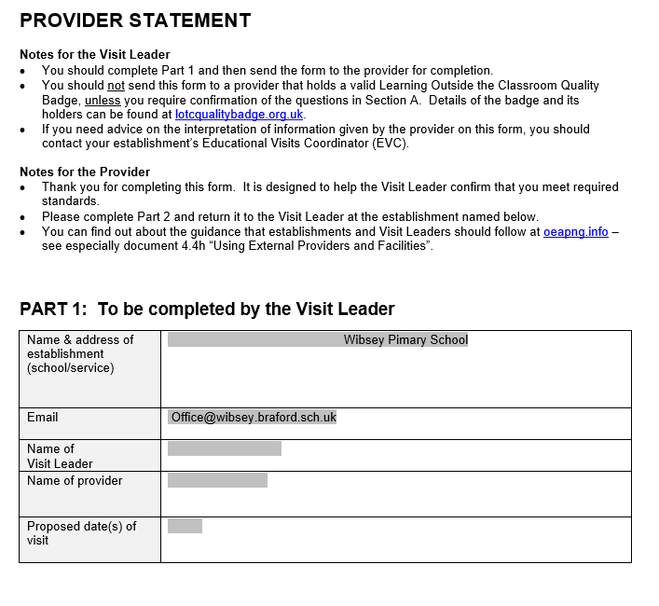

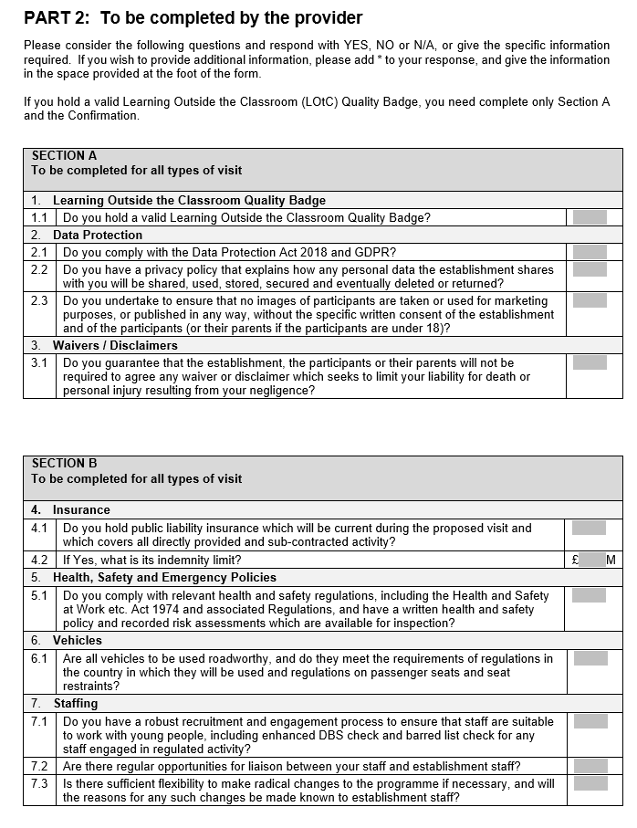

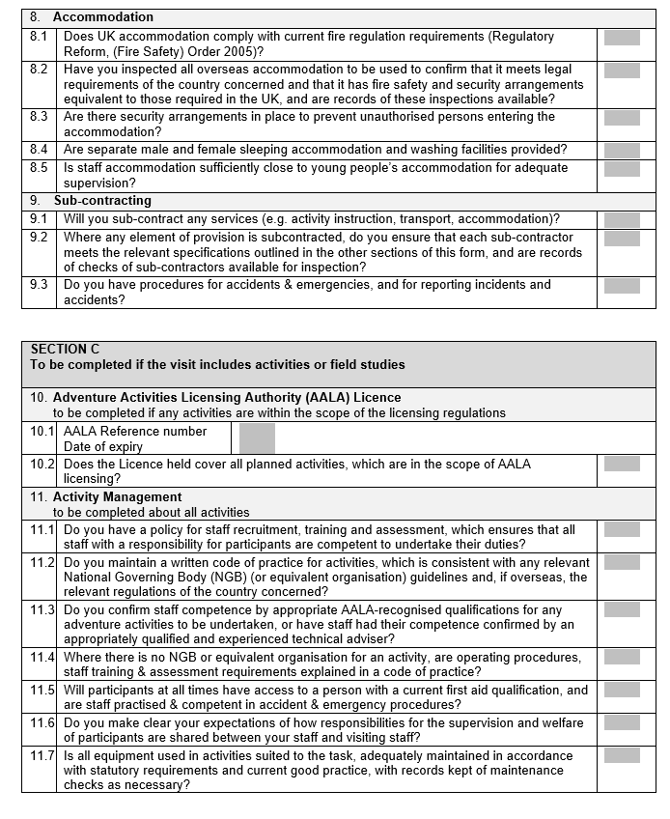

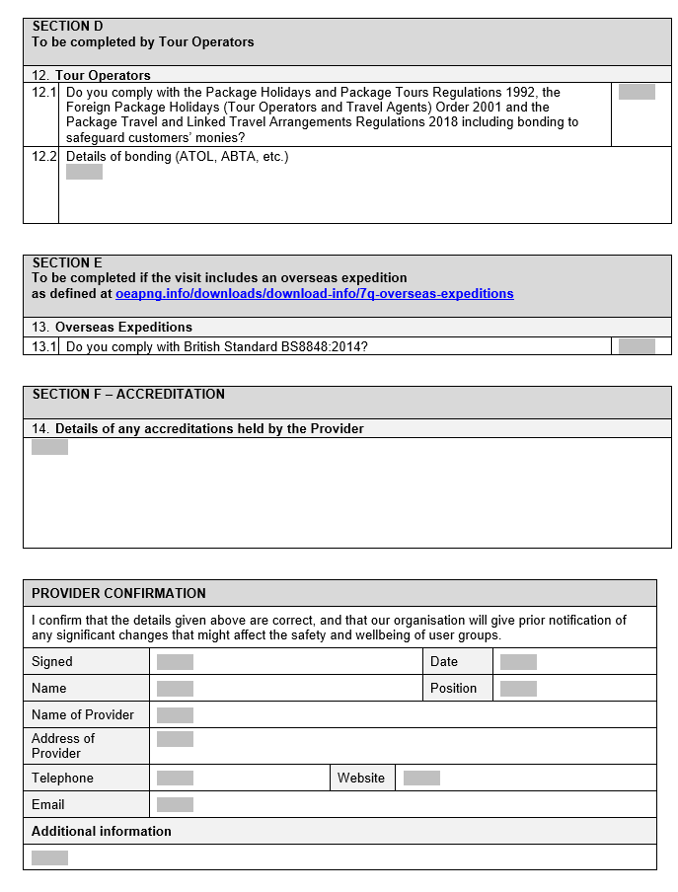

**Appendix 6: Risk Assessment**

|  |  |  |  |  |  |  |  |  |  |  |  |  |  |  |
| --- | --- | --- | --- | --- | --- | --- | --- | --- | --- | --- | --- | --- | --- | --- |
| Wibsey Web Logo  Wibsey Primary School  North Road, Bradford,  BD6 1RL  Specific Visit Risk Assessment | | | | | | **Date** | | December 5th 2022 | | | **Prepared by** | |  | |
| **EVC** | |  | | | **Date / Time** | |  | |
| **EVC’s signature** | |  | | |
| **Who is at risk?** | | A, B | |
| **Lead Teacher** | |  | | |
| **How many people affected?** | |  | |
| **Lead Teacher’s signature** | |  | | |
| **Visit to** | Judy Woods | | | | | **Year group / class** | |  | | | **Main hazards** | |  | |
| **Risk Rating**   |  |  |  | | --- | --- | --- | | **Likelihood** | **Severity** | **Risk Rating* (L x S)** | | 1 Unlikely | 1 No or Little Harm | 1-5 Low | | 2 Possible | 2 Minor/First Aid | 6-10 Medium | | 3 Probable | 3 Medical Attention | 10+ High | | 4 Likely | 4 Hospitalisation |  | | 5 Certain | 5 Death/Irreparable Injury |  | | | | | | | | | **Persons / groups at risk**   |  |  | | --- | --- | | A | Pupils | | B | Employees | | C | Public | | D | Volunteers | | E | Parents | | | | | Relevant Generic Risk Assessments   * Travel * Use of external provider * Visiting Farms * Lost Child | | |
| **What are the hazards and what could happen?** | | **Risk Rating** | **Who?** | **Existing Control Measures** | | | | | **Risk Rating with controls** | **Safety Notes**  **Further actions to eliminate risk** | | | **Action to be taken by** | **Risk rating with all controls** |
| Risks walking around Judy Woods.   * Stumbles / slips / or slippery ground and sustain an injury | | 4x4  16 | A/B | * All reminded to look carefully when they are walking around * Particular attention to be paid to obstacles at eye height, roots on ground and slippery mud * Correct supervision ratio with adults spread across   the group   * One to one support where needed * Careful supervision of behaviour throughout with appropriate action taken by adults * Children and adults to wear sturdy footwear * First aider to walk with children and to carry first aid kit | | | | | 2x2  4 |  | | | Staff  Pupils |  |
| Adversely cold weather   * Hypothermia * Children slip on ice | | 2x4  8 | A/B | * Children to wear a warm, waterproof coat and sturdy shoes * Lead to walk at the front of the group being vigilant for icy patches – alter route if needed | | | | | 2x3  6 | * Weather check on the morning of the visit – if it is too cold then the visit to be postponed to another day | | | Staff  Pupils | 1x1  1 |
| Lost Child (see generic RA) | | 4x3  12 | A | * Children will be advised of the risk of getting lost * Close supervision ratios (Adult 1:6 children) to be maintained. * Registers to be taken at beginning and end of activity. * Children to be advised never to go out of a clean line of site to the activity leader. * If a child is lost or reported lost they should follow the Lost child protocol | | | | | 2x3  6 | * A lost child should stand still and shout “1,2,3 I’m over here” and repeat until found. * The rest of the group should stay with one adult while the other adults spread out shouting “1,2,3 Where are you” repeatedly until the missing child is located. * The child should then be led back to the rest of the group and adults be made aware by mobile phone. | | | Staff  Pupils | 2x2  4 |
| Lead Teacher | |  | | | | | | | | Deputy Lead | | | |  |
| Staffing | |  | | | | | | | | Ratio | | | |  |
| Mini bus drivers | | Journey | | | Bus 1: | | Bus 2: | | | **Nursery and Early Years**, may be as low as: 1:2  **Reception** 1:5 **KS1** off-site on foot: 1:8  **KS1** visit by mini bus 1:7.5  **KS1** visit by public transport 1:6  **KS2** off-site on foot: 1:10  **KS2** visit by mini bus 1:7.5  **KS2** visit by public transport 1:8 | | | |  |
| Outbound & Return | | |  | |  | | |
| Driver cover staff (in school) | |  | | | | | | | |
| First aid / medication | |  | | | | | | | | School Mobile  (please highlight phone/s taken) | | | | 07544 023694  07544 023696 |

**Please note -** It is the group leaders responsibility to ensure all adult helpers receive a copy of the risk assessment two weeks prior to the visit and to leave the

original signed risk assessment at the office.

**Appendix 7**

**Wibsey Primary School**

**Emergency Management Plan**

1. Assess the situation
2. Safeguard the uninjured members of the group
3. Direct the First Aider to attend to the casualty / casualties and inform the emergency services if needed
4. Ensure any injured party is accompanied to hospital by First Aider (where possible)
5. Contact SMLT at school (01274 678016) – inform Head Teacher (HT) or Deputy Head Teacher (DHT).

If out of hours (residential) contact via personal mobile

1. Office to provide medical / personal information details to Group Leader for medical team.

If visit is residential, and the emergency is out of school hours, then Group Leader to provide contact details

1. Notify Police if needed
2. Head Teacher or Deputy Head Teacher to contact parent / carer and provide ‘on the ground’ contact details. HT / DHT to co-ordinate actions.
3. HT / DHT to inform LEA if needed (01274 431007). LEA to agree media strategy if needed
4. Take any telephone numbers that will be needed later;
5. Write down all the facts and witness details / contacts;
6. **No one should speak to the media and no names be given;**
7. **No one should discuss any legal liability with other parties.**
8. Debrief / review plan an update if needed
9. Whole staff / parent briefing, if needed