YEAR 6 HOME LEARNING DUE IN 04.09.23
Spellings to learn:  1. aggressive  2. hostile  3. awkward  4. obstinate  5. desperate  6. frantic  7. disastrous  8.calamitous  9. marvellous  10. spectacular | History  Think about your day to day life. Research how you think WW2 has impacted your life.  Reading Challenge:  Get involved in the Bradford Reading Challenge! | Maths  1. Mathletics  2. Times Table Rock Stars.  EARN SOME POINTS FOR YOUR CLASS!  3. Complete Reasoning Quiz 2

Year 6 Reading Challenge!
Over the holidays, try to complete as many of these reading challenges as possible. Tick and date the ones you have completed, and return to your new class teacher after half term.
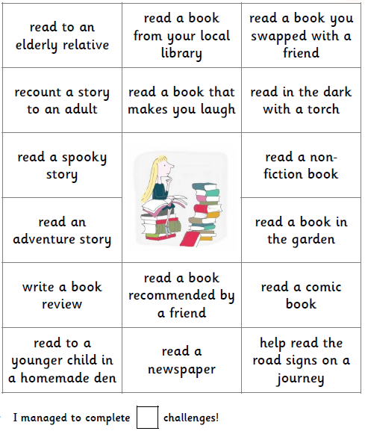

read a selection of poems

read a picture book

read on the move! A car, bus or train

Here is a photograph of me completing one of the Reading Challenge tasks:

Tell us:
- What you are reading.
- Why you chose that book to read.
- Did you enjoy this book?
- Why did you choose to photograph this task? Was it exciting? Was it your favourite?
- Would you recommend this book to a friend in your class? Explain why.
__________________________________________________________________________________________________________________________________________________________________________________________________________________________________________________________________________________________
______________________________________________________________________________________________

Make sure you get whoever you read with to comment in your reading journal about which task you have completed and how excellent your reading is!

