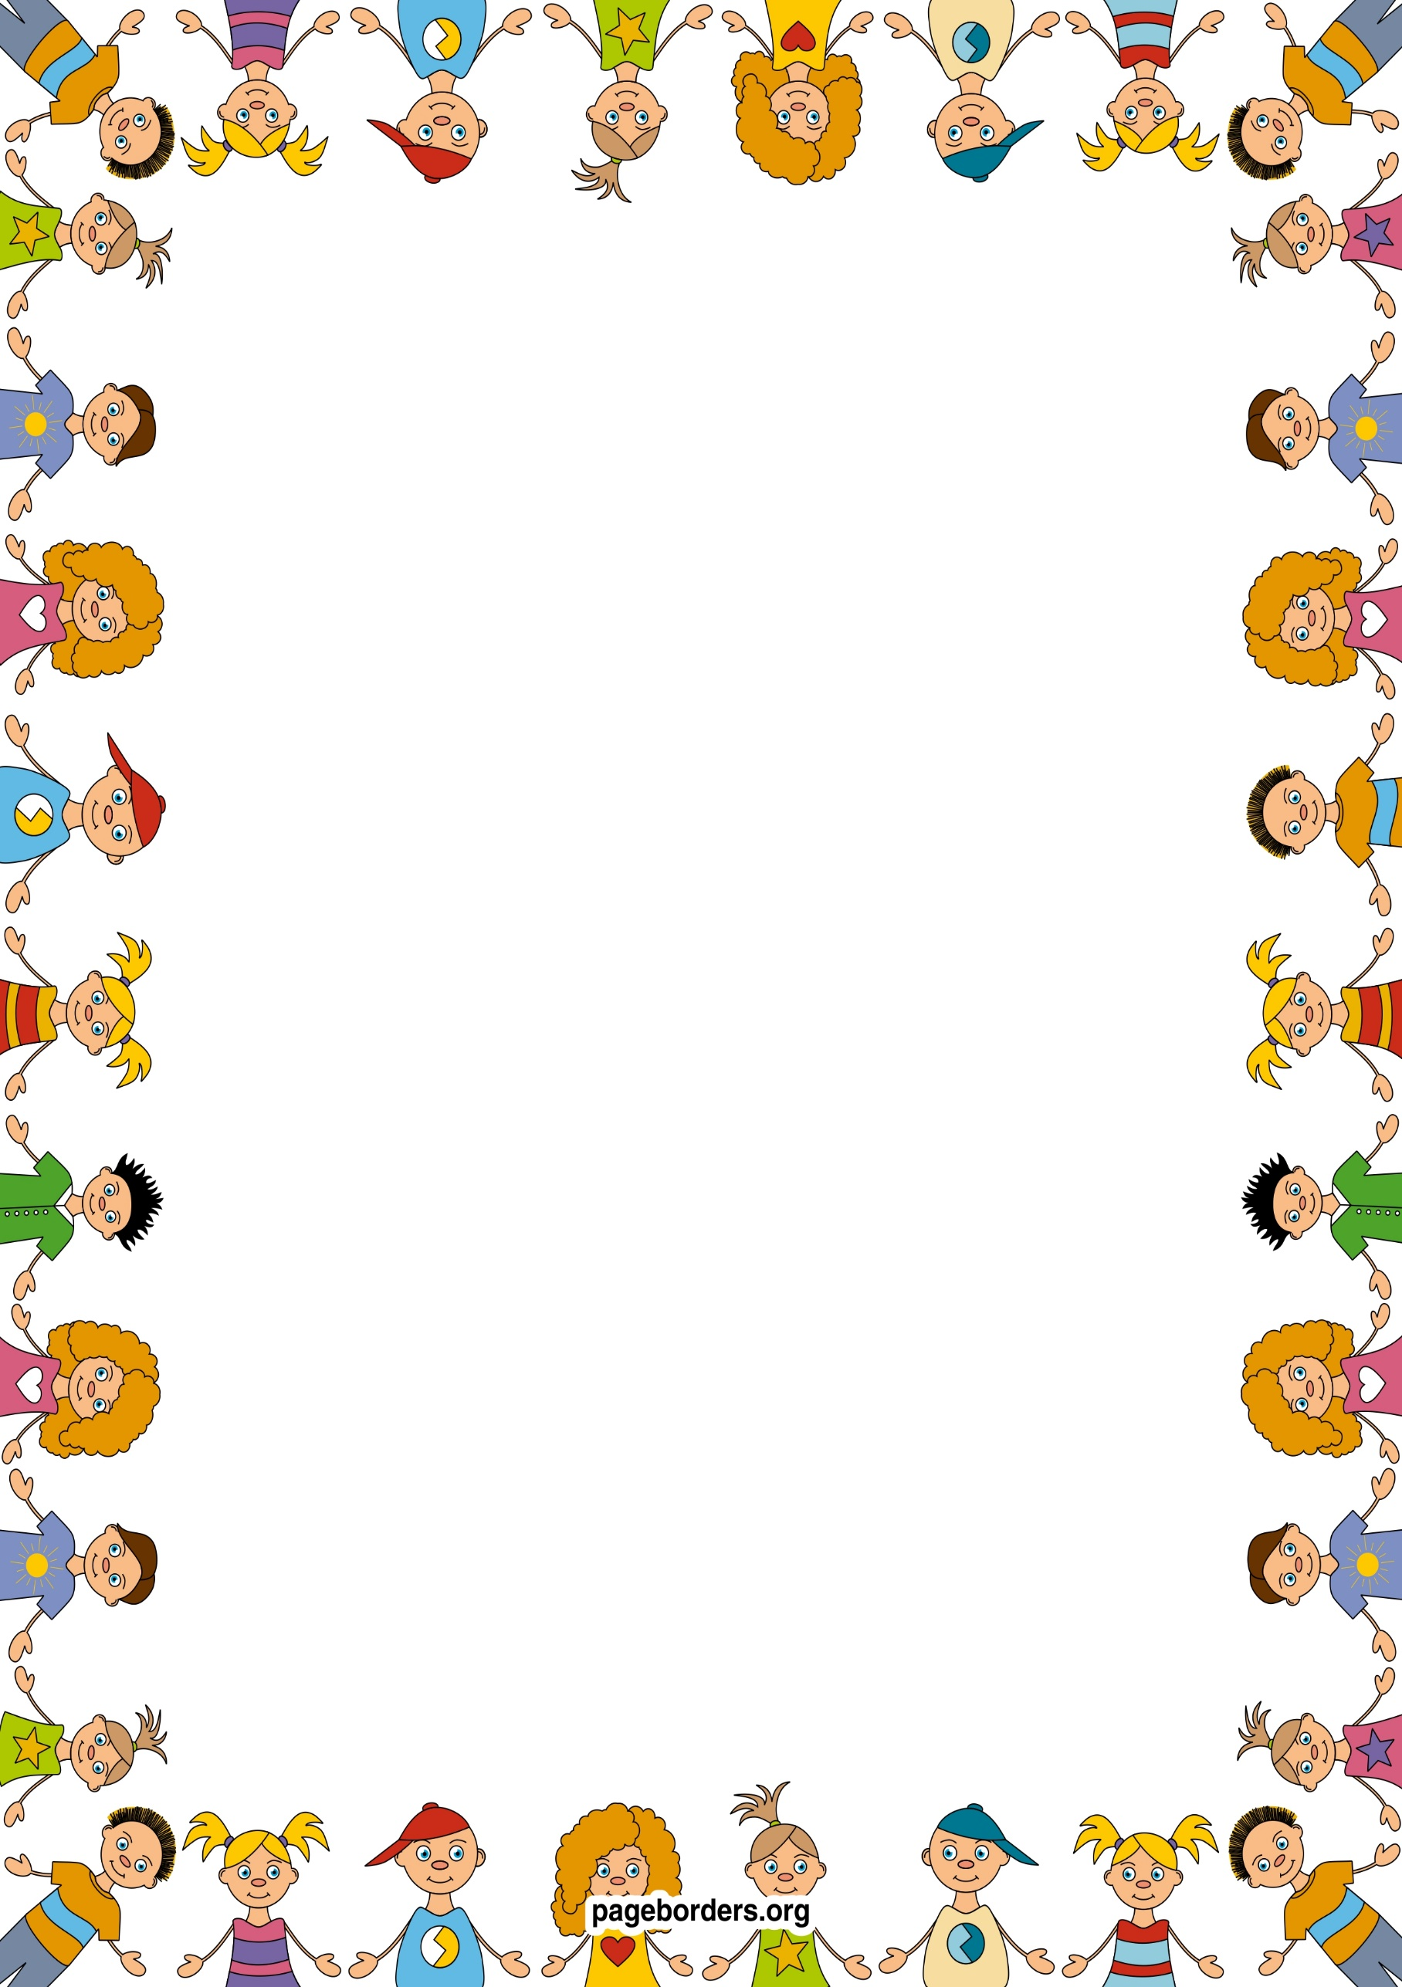 an

## As someone who is aware of our world (UW)

* **I will visit our local area, take photographs and make a simple map.**
* **I will learn about different cultures and celebrations – eg. St George`s Day and why it is important to English people, Eid Al Fitr and why it is important to Muslim people.**
* **I will learn about my own history through special days such as Fathers` Day.**
* **I will learn about farm animals and their young.**
* **I will learn about lifecycles, including that of a butterfly.**

## As a confident communicator(CL)

* **I will be listening to longer stories and answering questions about them.**
* **I will be learning how to speak in longer sentences.**
* **I will be learning new vocabulary through stories, rhymes, songs.**
* **I will be learning how to engage in longer conversations with my friends and adults.**
* **I will be learning how to use the correct tense in spoken language.**

## As a mathematician (M)

* **I will continue to recognise groups of 1, 2,3,4, 5 objects without counting, in different contexts.**
* **I will develop my counting skills, counting groups and items that can be moved, by lining them up and touching each item, saying a number for each item.**
* **I will be learning to count, recognise and order numbers 1-5.**
* **I will be learning how to share quantities and amounts fairly.**
* **I will learn to recite numbers 1-20.**
* **I will continue to explore 2d shapes and use 3d shapes in play – eg building/constructing models.**

## As a healthy and active person (PD)

* **I will collaborate with others to manage large items, such as moving a long plank safely, carrying large hollow blocks.**
* **I will develop ball skills in PE lessons and by using what I have learned in play.**
* **I will start taking part in some group activities which I have made up with my friends.**
* **I will continue to develop my fine motor skills, by using tools in construction, in `funky fingers` activities – e.g threading, using tweezers and by using a pencil correctly.**

## As an artist and designer (EAD)

* **I will continue to develop my repertoire of songs and rhymes.**
* **I will learn about rhythm and beat in music – marching and dancing in time.**
* **I will be developing a narrative when working with small world resources.**
* **I will explore the use of different materials to build and construct**
* **I will learn to draw with increasing complexity and detail, such as representing an animal with a circle, including details like legs, tail etc.**

## As a reader and writer (L)

* **I will be learning about alliteration in stories and games.**
* **I will continue to develop my pencil control when drawing and mark making.**
* **I will learn to write my name by copying.**
* **I will learn that text has meaning and that we read it from top to bottom, left to right, in English.**
* **I will play more games that will help me blend and segment words.**
* **I will play more games that will help me to hear and say rhyming words.**
* **I will learn the names of the picture cards in our phonics scheme.**

**Nursery: Summer 1 Term 2024**

**Old Mc Donald had a farm!**

**As a caring and independent person (PSED)**

* **I will be supported to develop confidence in new social situations.**
* **I will be learning how to be assertive in appropriate ways.**
* **I will learn how to play games with rules and understand the need for turn taking.**
* **I will be learning how to solve conflict.**
* **I will be learning about the importance of healthy eating and where our food comes from.**
* **I will continue to develop my understanding of exercise to develop a healthy lifestyle.**