**Year 3 Autumn 1**

We are having a fantastic half term and we wanted to share some of the amazing things that we have been doing with you!

Our Learning Challenge Question this half term is ‘Developing a Healthy Lifestyle’ and we really enjoyed our SCARF visit from Harold and Jane.

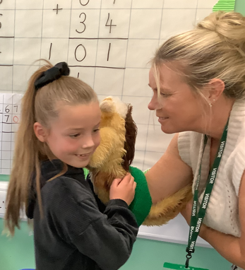

We used a special t-shirt to find out about the skeletal system and in Science we labelled the bones of a skeleton.

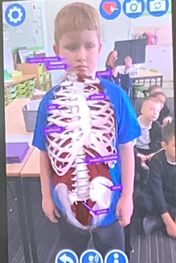

Bradford 2025 is the next UK City of Culture and we have already started the countdown. We worked with the Royal Opera House as part of a ‘Leap, Dance, Sing’ project where we thought about our favourite places in Bradford.

