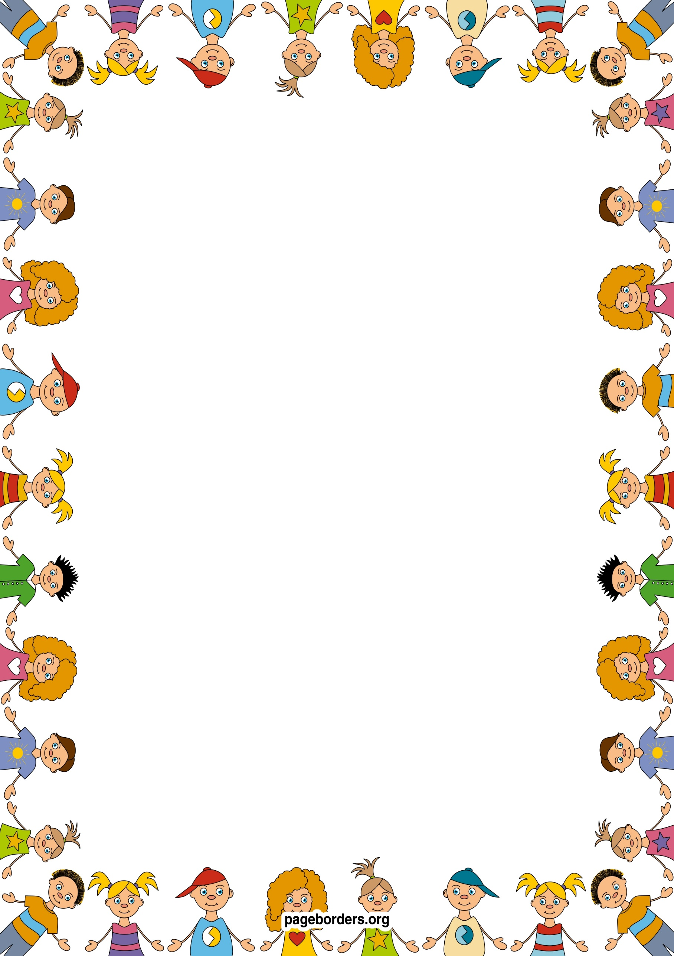 an

## As a mathematician (M)

* **I will be learning to recognise groups of 1, 2,3 objects without counting.**
* **I will be learning to count carefully to 5.**
* **I will be learning to count, recognise and order numbers 1-5.**
* **I will be learning to match numbers to quantities of groups 1-5.**
* **I will be learning to recite numbers 1-10.**
* **I will be learning to name and describe simple 2D shapes.**
* **I will be learning to create repeating patterns.**

## As a reader and writer (L)

* **I will be learning to recognise my name and begin to copy the letters in my name.**
* **I will learning how to use a pencil correctly, with the correct grip.**
* **I will be learning how to talk about books I enjoy and begin to join in with familiar stories.**
* **I will play listening games to help me learn about different sounds.**

## As a healthy and active person (PD)

* I will be developing body strength, co-ordination, balance and agility.
* I will be learning how to use a balance bike safely.
* I will be learning how to use one handed tools and equipment and how to hold a pencil correctly.
* I will be learning how to move across an obstacle course in different ways
* I will be learning how to work with others to carry large resources – planks, bricks etc.

**Nursery: Autumn 2 Term 2024/25**

**Congratulations and celebrations!**

## As an artist and designer (EAD)

* **I will make cards for special celebrations.**
* **I will design and create celebration crafts – eg.diva lamps, Christmas stockings.**
* **I will be learning new songs and rhymes and poems.**
* **I will be acting out stories with puppets and small world resources.**
* **I will be learning about colour and how to make my own colours.**
* **I will be learning how to use colours for a specific purpose.**
* **I develop performance skills in front of a small audience.**

**As a caring person (PSED)**

* **I will be following our class rules and will be able to say why they are important.**
* **I will be learning how to talk about my feelings, using words like happy, sad, angry or worried.**
* **I will be learning how to negotiate with my friends to solve problems.**
* **I will be learning how to put on my own coat and shoes and to become more independent.**
* **I will be learning and talking about special times for my family and for others.**

## As a confident communicator(CL)

* **I will be learning to talk about special times that are important to me.**
* **I will be learning how to speak in full sentences.**
* **I will be learning new vocabulary through stories, rhymes, songs.**
* **I will be learning how to take turns in conversation with my friends and adults in school.**

## As someone who is aware of our world (UW)

* **I will be learning about weather patterns and seasonal changes.**
* **I will learn the days of the week and months of the year.**
* **I will learn about different celebrations, including Bonfire night, Divali and Christmas.**
* **I will learn how to bake buns and biscuits and learn how the ingredients change when we heat them.**