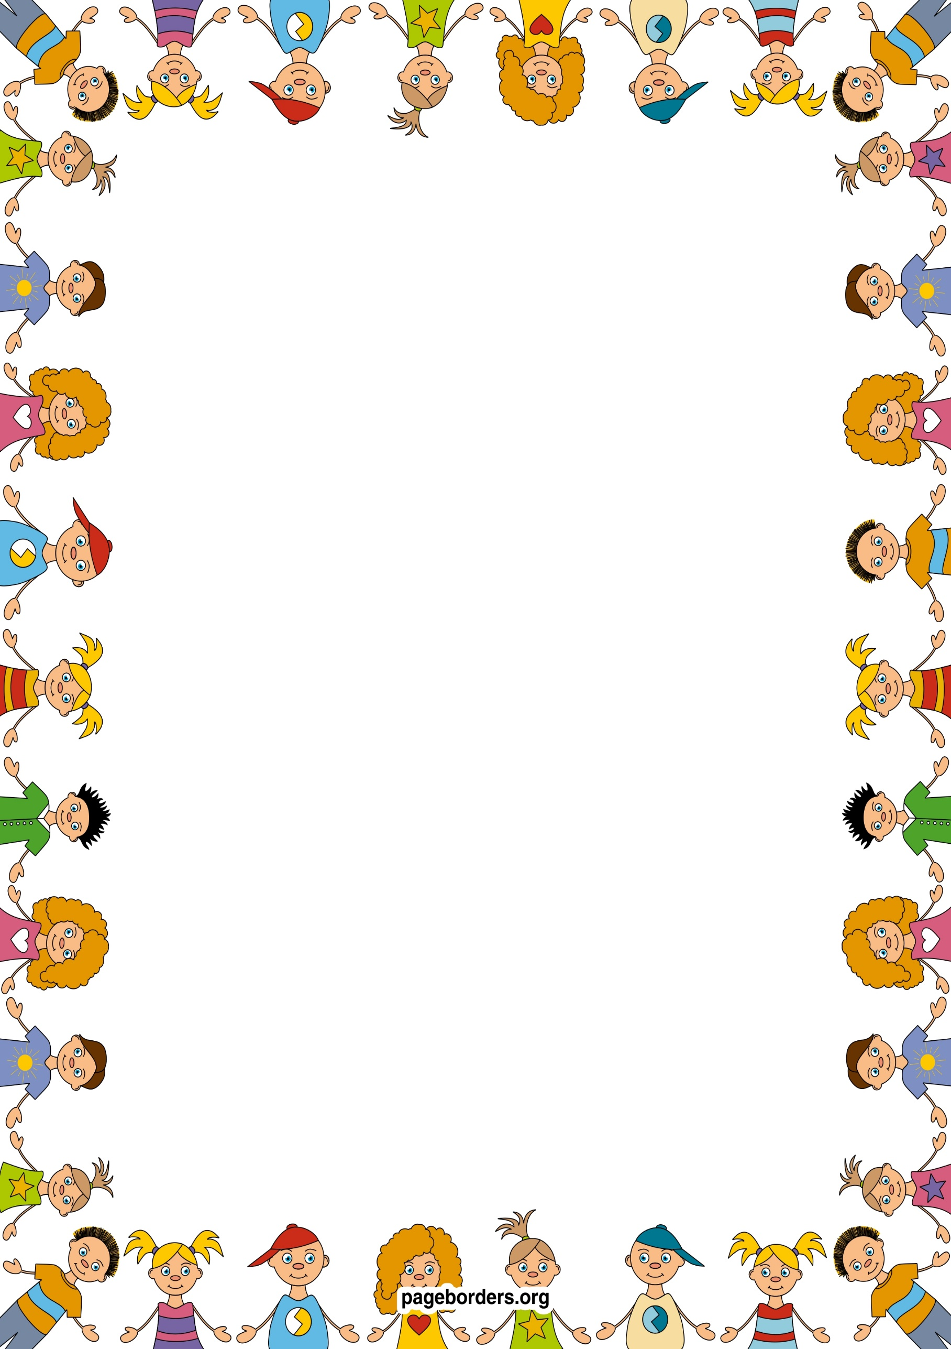 an

## As a reader and writer (L)

* **I will be learning to recognise my name and begin to copy the letters in my name.**
* **I will learning how to use a pencil correctly, with the correct grip.**
* **I will draw and describe my own pictures and give meaning to marks.**
* **I will be learning how join in with and retell traditional stories.**
* **.I will play games to help me hear the sounds at the beginning of words.**
* **I will play games that help me to blend sounds together to say words**.

## As an artist and designer (EAD)

* **I will learn about the skills of baking and use this to support mathematical and language development.**
* **I will be learning new songs and rhymes and poems.**
* **I will have weekly music sessions with a music specialist and learn how to use musical instruments appropriately**
* **I will be acting out stories with puppets and small world resources.**
* **I will be learning about colour and how to make my own colours.**
* **I will be learning how to construct and make models and how to join pieces together**

## As a confident communicator(CL)

* **I will be learning to talk about special times that are important to me.**
* **I will be learning how to speak in full sentences.**
* **I will be learning new vocabulary through stories, rhymes, songs.**
* **I will learn how to join in with and retell stories in my own words.**
* **I will be learning how to use the correct tense in spoken language.**

## As someone who is aware of our world (UW)

* I will be learning about weather patterns and seasonal changes.
* I will learn about our local environment.
* I will learn about different cultures through stories and experiences – eg. Chinese New Year, Shrove Tuesday.
* I will learn about past and present through stories and personal experiences and memories.
* I will learn about freezing and melting through hands on exploration.

## As a healthy and active person (PD)

* I will be developing body strength, co-ordination, balance and agility.
* I will access hand strengthening activities to support writing.
* I will be learning how to use one handed tools and equipment and how to hold a pencil correctly.
* I will have weekly PE sessions with a PE coach to work on physical development.
* I will access large motor activities to develop core strength.

## As a mathematician (M)

* **I will be learning to recognise groups of 1, 2,3,4, 5 objects without counting.**
* **I will be learning to count carefully to 5/10.**
* **I will be learning to count, recognise and order numbers 1-5.**
* **I will be learning to match numbers to quantities of groups 1-5.**
* **I will be learning to recite numbers 1-10.**
* **I will be learning to show fingers to show numbers 1-5.**
* **I will be learning to name and describe simple 2D shapes.**
* **I will be learning to create repeating patterns.**

**Nursery: Spring 1 Term 2024/2025**

**Once upon a time…..**

**As a caring and independent person (PSED)**

* **I will be following our class rules and will be able to say why they are important.**
* **I will be learning how to talk about my feelings, using words like happy, sad, angry or worried**
* **I will be learning how to negotiate with my friends to solve problems.**
* **I will be learning about the importance of healthy eating**
* **I will be learning about the importance of oral health and toothbrushing.**