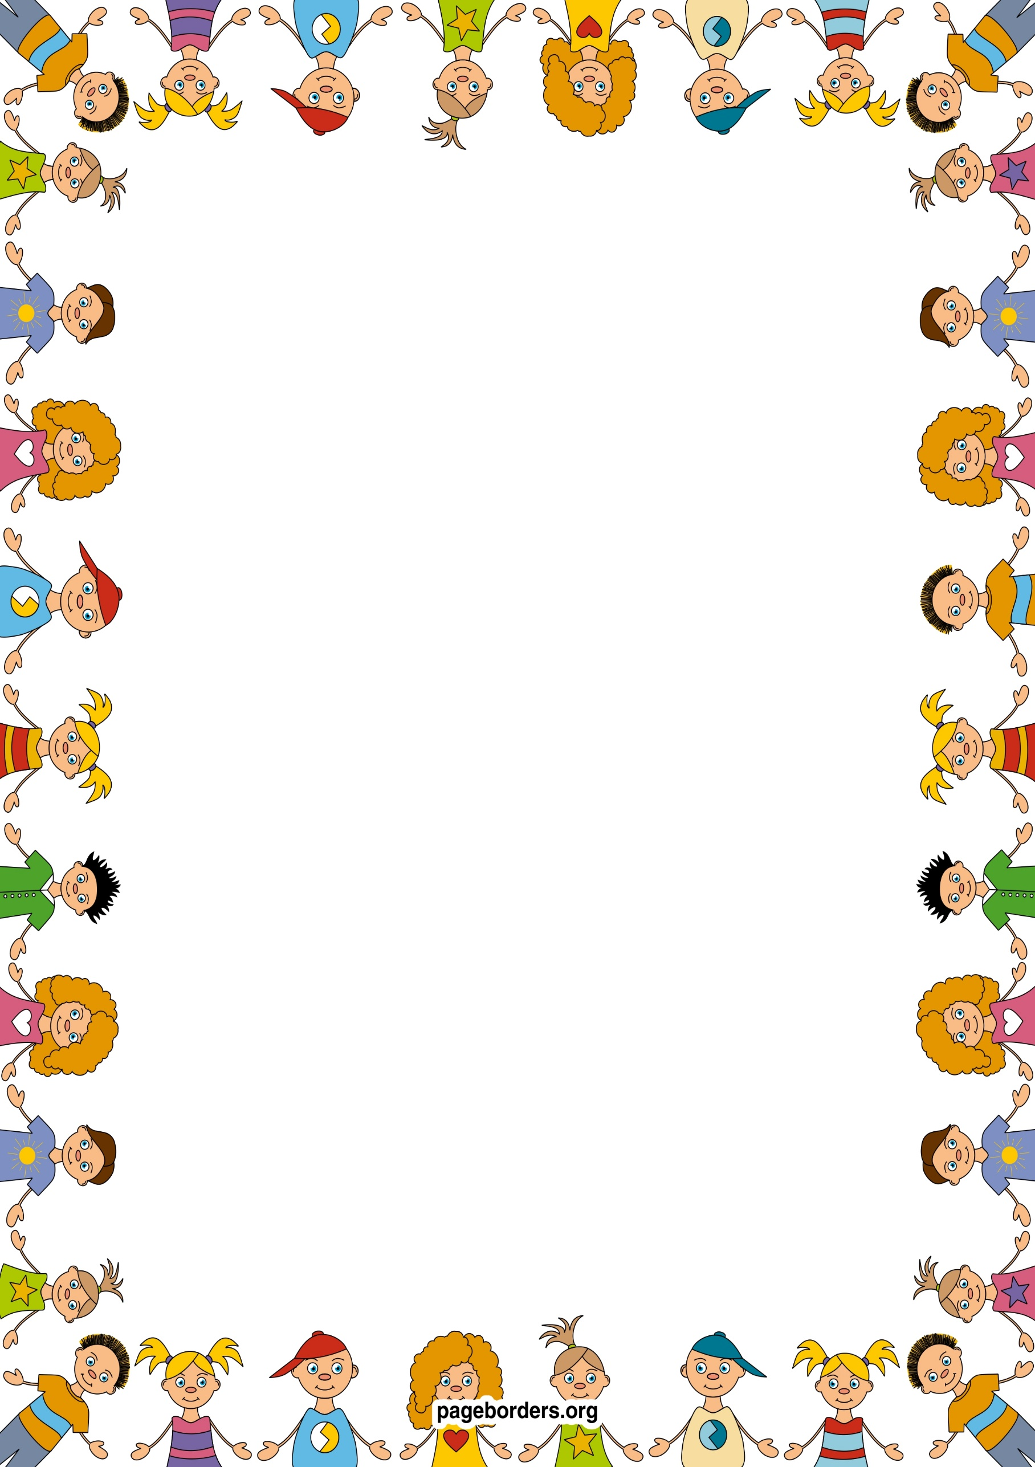 an

## As someone who is aware of our world (UW)

* **I will learn about weather patterns and seasonal changes.**
* **I will learn about different cultures and celebrations – eg. Easter and why it is important to Christians**
* **I will learn about my own history through special days such as Mothers` Day**
* **I will learn about the past through our class Learning Journey, remembering important occasions.**
* **I will learn about what plants need to grow and thrive.**

## As a confident communicator(CL)

* **I will be listening to longer stories and answering questions about them.**
* **I will be learning how to speak in longer sentences.**
* **I will be learning new vocabulary through stories, rhymes, songs.**
* **I will be learning how to engage in longer conversations with my friends and adults.**
* **I will be learning how to use the correct tense in spoken language.**

## As a healthy and active person (PD)

* I will learn to choose the right resources to carry out my own plan, for example, choosing the right item of gardening equipment to dig small and large holes.
* I will learn how to ride balance bikes safely.
* I will access large motor activities to develop core
* strength – for example, digging in our mud pit, sweeping our outdoor area.
* I will become more independent and will learn how to do up my zip on my coat and put on my own shoes.
* I will continue to develop my mark making skills, using a pencil with a preferred hand and good control.

## As an artist and designer (EAD)

* **I will continue to develop my repertoire of songs and rhymes.**
* **I will continue to develop the confidence to perform in front of a small audience.**
* **I will learn how to keep the pulse in music.**
* **I will be acting out stories with puppets and small world resources.**
* **I will continue to explore the use of colour for specific purposes.**
* **I will be learning about collage and how to represent a spring scene, flowers and plants.**

## As a reader and writer (L)

* **I will be learning to recognise my name and begin to copy the letters in my name.**
* **I will learning how to use a pencil correctly, with the correct grip.**
* **I will make marks and ascribe meaning to them, sometimes forming letter shapes – eg. `writing` a shopping list.**
* **I will learn the names of different parts of a book.**
* **I will play games to help me blend and segment words.**
* **I will play games that help me to hear and say rhyming words.**

## As a mathematician (M)

* **I will continue to recognise groups of 1, 2,3,4, 5 objects without counting, in different contexts.**
* **I will be learning to count carefully to 5/10.**
* **I will be learning to count, recognise and order numbers 1-5.**
* **I will be learning to compare quantities and use the mathematical terms of more/fewer.**
* **I will be learning to recite numbers 1-10.**
* **I will continue to explore shape, discussing similarities and differences of shapes in the environment.**
* **I will be learning about capacity through water play.**

**Nursery: Spring 2 Term 2024/25**

**Roots, shoots and muddy boots…..**

**As a caring and independent person (PSED)**

* **I will learn about our school community and develop a sense of belonging and pride**
* **I will be learning how to be assertive in appropriate ways.**
* **I will be learning how to negotiate with my friends to solve problems.**
* **I will be learning about the importance of healthy eating and where our food comes from**
* **I will be learning about the importance of exercise in a healthy lifestyle.**