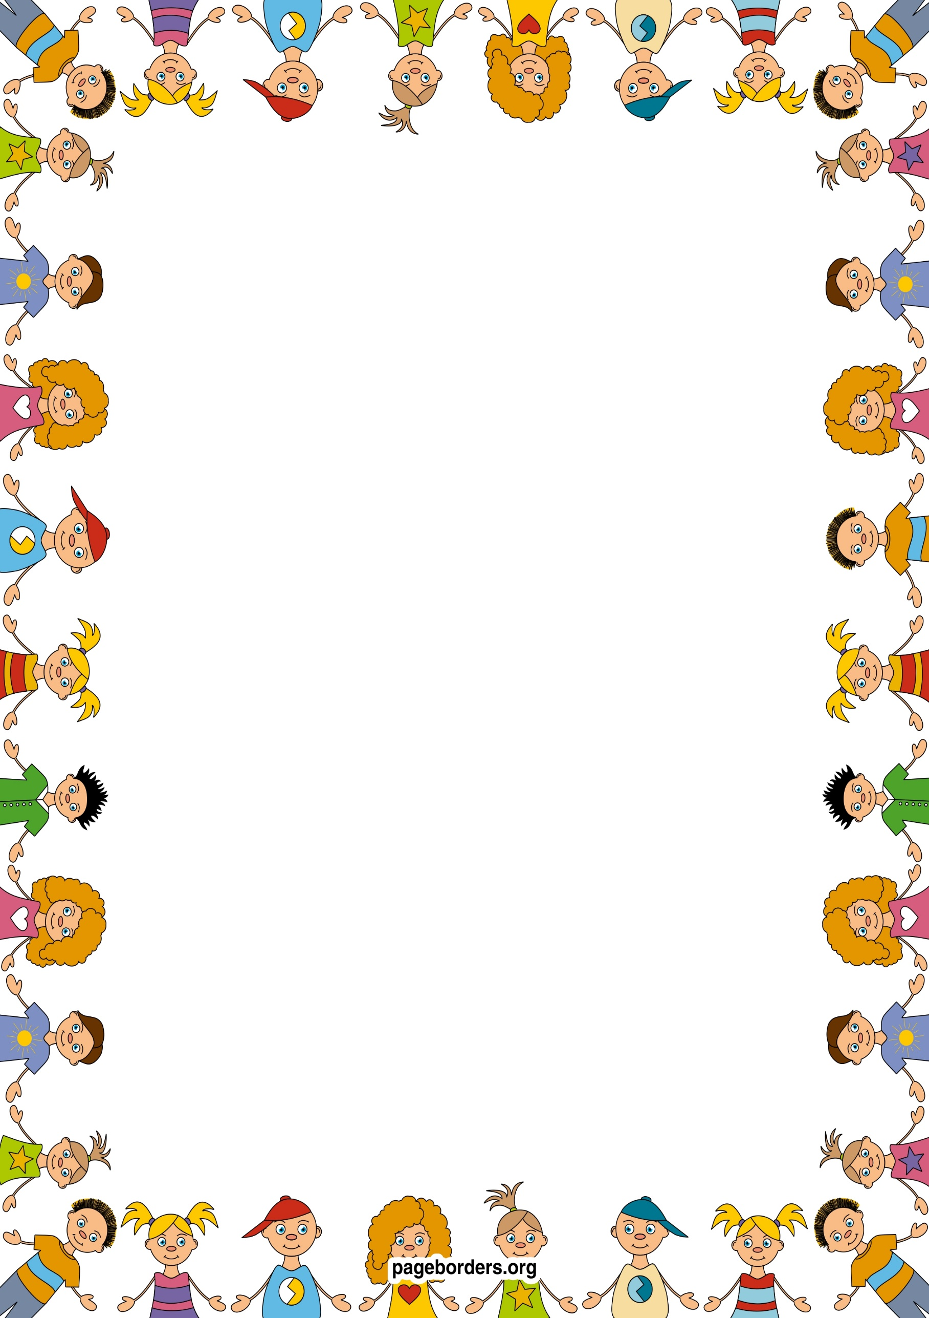 an

## As an artist and designer (EAD)

* **I will listen with increased attention to sounds.**
* **I will respond to what I have heard, expressing thoughts and feelings.**
* **I will remember and sing entire songs.**
* **I will play instruments with increasing control to express my feelings and ideas.**
* **I will** **explore different materials freely, to develop their ideas and then decide which materials to use to express them.**
* **I will build and construct models – eg. a train, bus, car and learn how to join different components together.**

## As a healthy and active person (PD)

* **I will continue to develop movement, balance and riding skills.**
* **I will be learning how to hop, skip, stand on one leg by playing games.**
* **I will learn sequences and patterns of movements related to rhythm in music.**
* **I will become increasingly competent, using one handed tools and equipment, developing an effective pencil grip.**
* **I will be learning about the importance of healthy eating and where our food comes from.**
* **I will continue to develop my understanding of exercise to develop a healthy lifestyle.**

## As a mathematician (M)

* **I will experiment with marks, symbols and numerals to represent amounts.**
* **I will learn how to solve real life mathematical problems with numbers up to 5.**
* **Talk about and explore 2D and 3D shapes using informal and mathematical language: ‘sides’, ‘corners’; ‘straight’,‘flat’, ‘round’.**
* **Understand position through words alone – for example, “The bag is under the table,” – with no pointing.**
* **Make comparisons between objects relating to size,length, weight and capacity.**

## As a confident communicator(CL)

* **I will be using a wider range of vocabulary, prompted by my experiences in school.**
* **I will understand ‘why’ questions, like: “Why do you think the caterpillar got so fat?”**
* **I will learn how to express a point of view and to debate when I disagree with an adult or a friend, using words as well as actions.**
* **I will be able to start a conversation with an adult or a friend and continue it for many turns.**

## As someone who is aware of our world (UW)

* **I will learn about forces – eg. push/pull, friction as we learn about transport and different methods of travel.**
* **I will learn about different cultures and celebrations –Eid ul fitr and why it is important to Muslim people.**
* **I will learn about different jobs and how people lived in the past.**
* **I will make ice lollies and learn about freezing and melting**.

## As a reader and writer (L)

* **I will be learning about alliteration in stories and games.**
* **I will continue to develop my pencil control when drawing and mark making.**
* **I will learn to write my name by copying.**
* **I will learn that text has meaning and that we read it from top to bottom, left to right, in English.**
* **I will play more games that will help me blend and segment words.**
* **I will play more games that will help me to hear and say rhyming words.**
* **I will learn the names of the picture cards in our phonics scheme.**

**Nursery: Summer 2 Term 2024/25**

**Are we nearly there yet?**

**As a caring and independent person (PSED)**

* **I will develop a sense of responsibility for the people and resources in our Nursery.**
* **I will be able to extend play with a group of children and collaborate in whole class activities.**
* **I will remember rules without adult support.**
* **I will understand how others might feel and consider my actions.**
* **I will become increasingly independent and take responsibility for getting dressed, brushing my teeth and going to the toilet and washing my hands.**
* **.**