Year 3 Autumn 1
We are having a fantastic half term and we wanted to share some of the amazing things that we have been doing with you!
Our Learning Challenge Question this half term is ‘Developing a Healthy Lifestyle’ and we really enjoyed our SCARF visit from Harold and Jane.
We used a special t-shirt to find out about the skeletal system and in Science we labelled the bones of a skeleton.
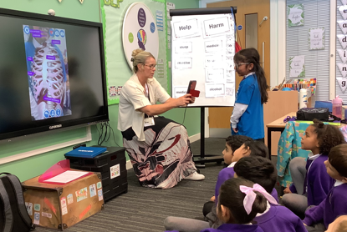
In PE we have been learning ball skills. We have been throwing and catching, practising football and basket ball skills and we have played some team games.
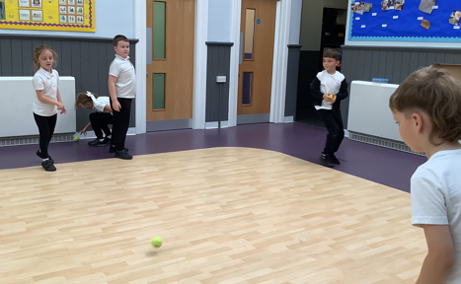
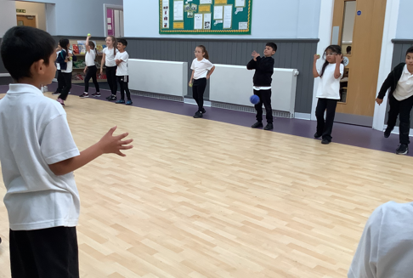

In DT we have been learning about different structures. We found out about lots of different types of bridges. We designed and made our own bridge and then we tested it to see how strong it was.
