Year 3 Autumn 2
We have had a fantastic half term and we wanted to share some of the amazing things that we have been doing with you!
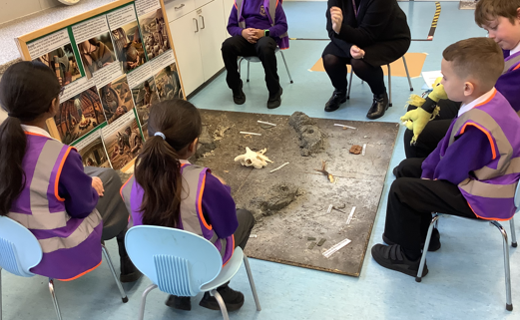
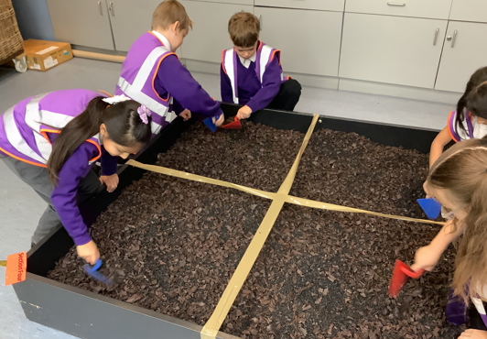
In History this half term we enjoyed finding out all about the Stone Age. We all enjoyed our school trip to Cliffe Castle. Our favourite part was when we became archaeologists and dug up artefacts from the Stone, Bronze and Iron Age.
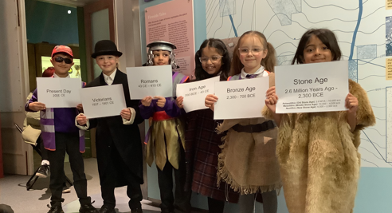

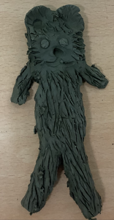
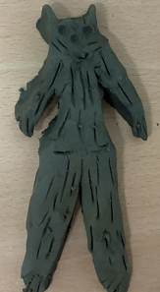
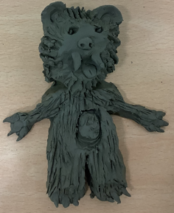
In Art, we looked at sculptures. We researched different sculptures, looked at how they were made, what they were made from and why they were made. We then looked at a Stone Age sculpture: The lion-man. Here are some of our amazing lion-man sculptures we made using clay.

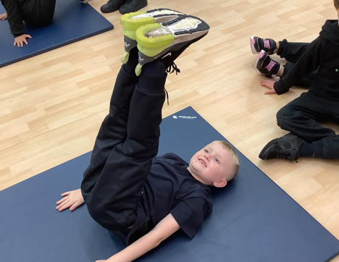
In PE this half term we have been doing gymnastics. We have enjoyed learning new balances, how to do a cartwheel and how to do different jumps and leaps.

