Year 3 Spring 2
We are having a fantastic half term and we wanted to share some of the amazing things that we have been doing with you!
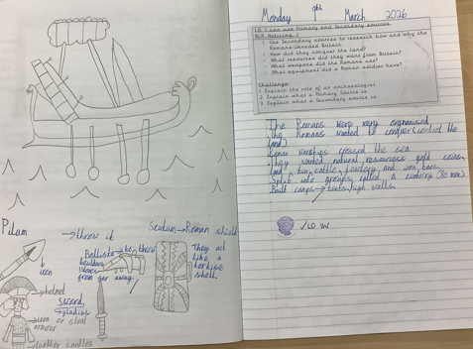
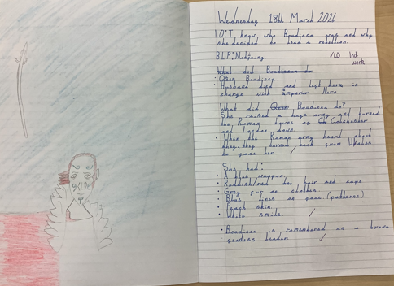
In History, we have been learning all about the Romans. We have found out how and why they invaded Britain. We have researched to find out about the armour and weapons soldiers would have used. We have also used secondary sources to look at significant figures such as Julius Caesar and Boudicca.
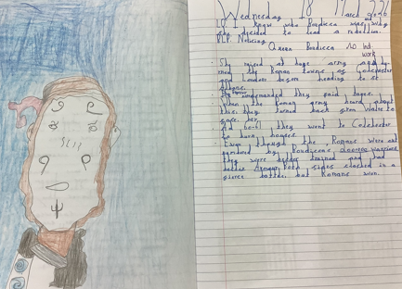
In Art, we have been looking at Roman mosaics. We have imitated some real mosaics before designing and making our own. Here are some pictures of us making our mosaics.
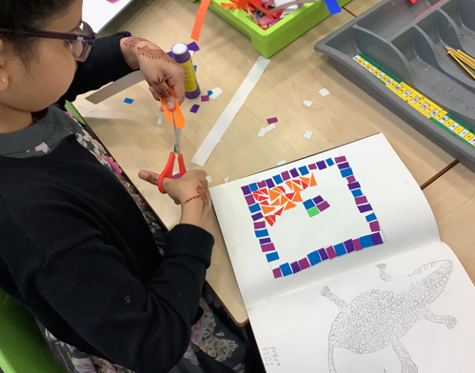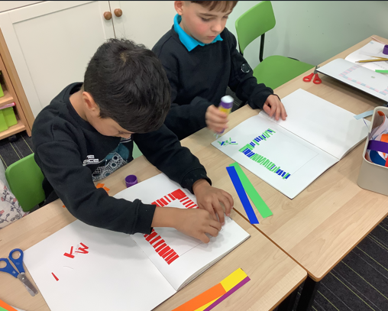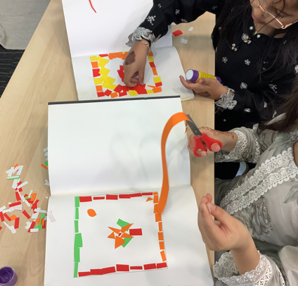

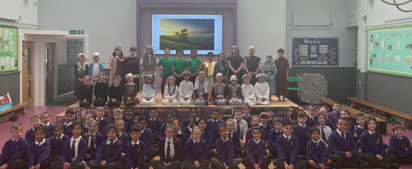
We have really enjoyed practising and performing our Easter production for you. Our teachers were very proud of our beautiful singing, confident acting and the brilliant solos performed by the trees! Thank you for coming to watch us perform!

