Year 3 Summer 1
We are having a fantastic term and would like to share an update with you of what we have been up to!

Our learning challenge question this half term is ‘Why do we have a shadow?’ We have been learning about light and shadows in Science, planning many scientific enquiries to look at reflective materials, the difference between opaque, translucent and transparent and how our shadows can change throughout the day.
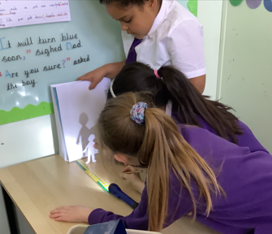
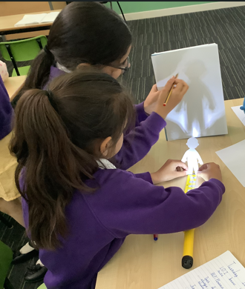
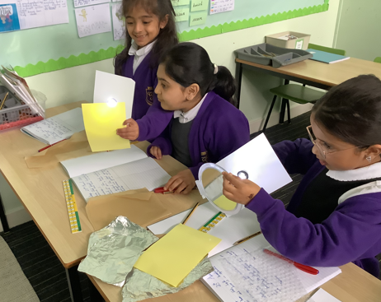

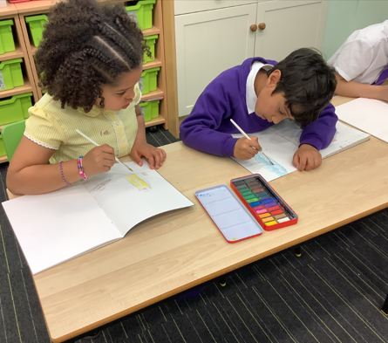
In Art, we have been looking at the artist Giorgio Morandi. We have imitated his skills of still-life drawing to create our own pieces of work. Here are some fantastic examples:
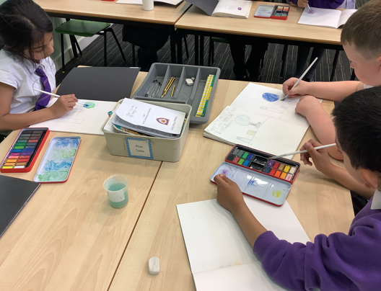
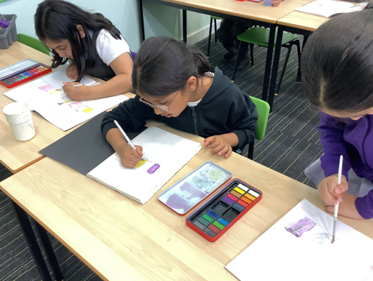

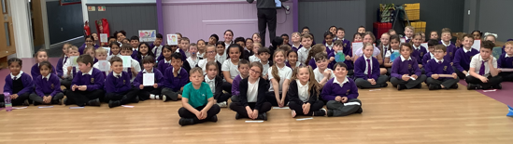
We really enjoyed sharing what we have learnt this half term with you in our BLP assembly. Thank you for coming to join us!

